How to Docusign Set up Docs

1. Complete templates
2. Signing docs order:
   1. Membership Letter / s
   2. Appointment of Administrator
   3. Bankers Resolution* for SSAS Lite Specifically
   4. Services Agreement
3. Signing people order
   1. Trustee (director)
   2. Trustee (others)
   3. David Nicklin (consultant) - davidn@retirement.capital
   4. Emily McAlister (assistant/ supplied) - emily@retirement.capital
   5. Veronica Walkman - (veronica@retirement.capital) - CC, not sign
4. Email: “Please Docusign the *Name of Scheme* Set up Documentation”

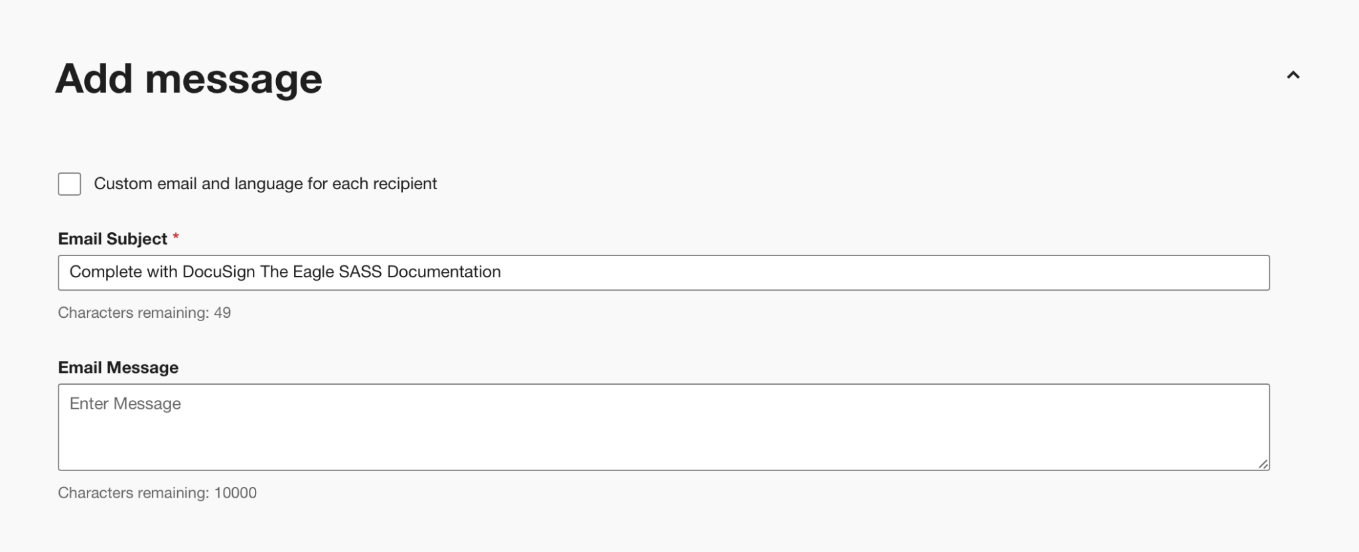

1. All Dates on Docs is input by the First Trustee

**Membership Letter**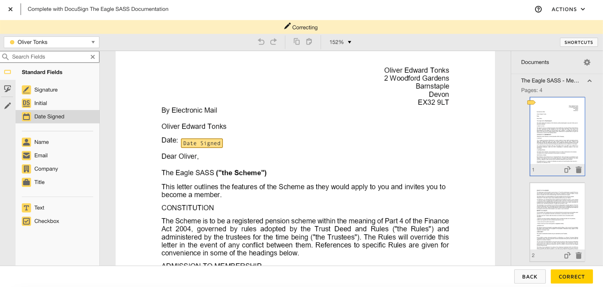

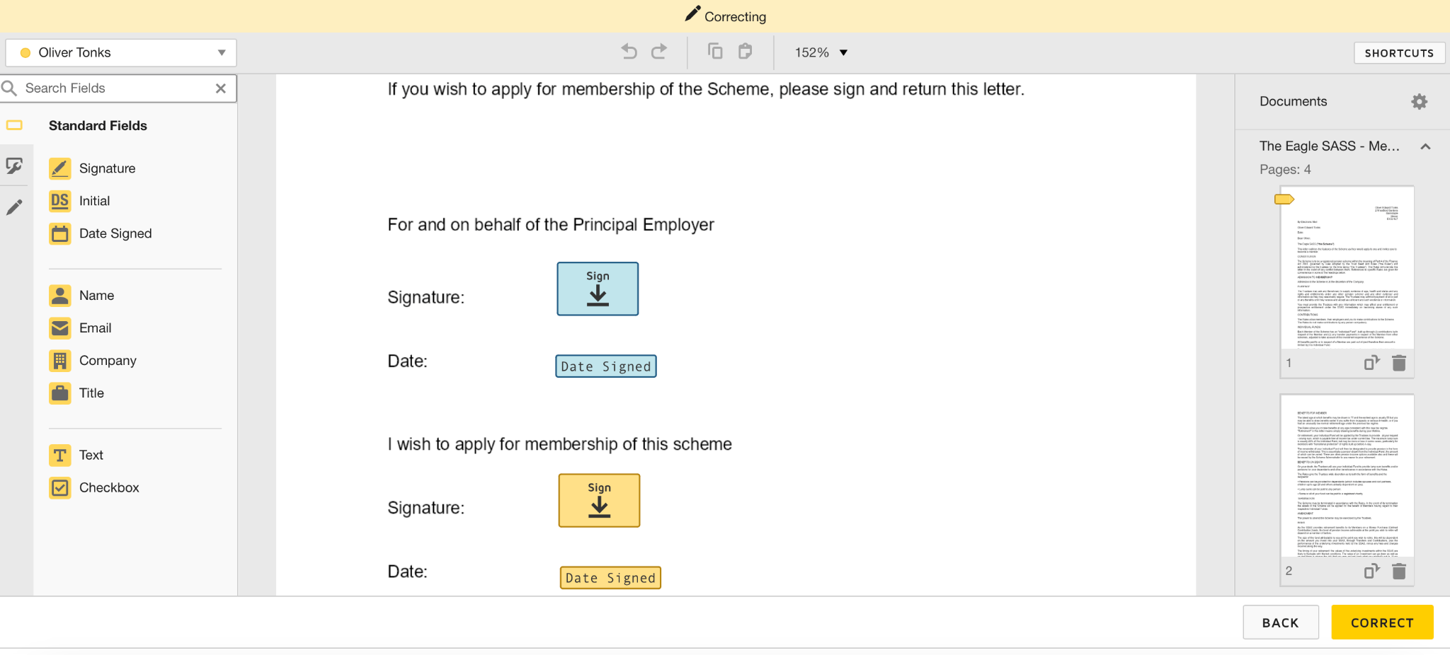

* Oliver and Sophie are both the directors of the company, so they can sign for and on behalf of the Principal Employer on Membership Apps for each other

BUT

** If only 1 of the trustee is a director, then it is only him/her to sign for and on behalf of the Principal Employer on BOTH Membership Apps

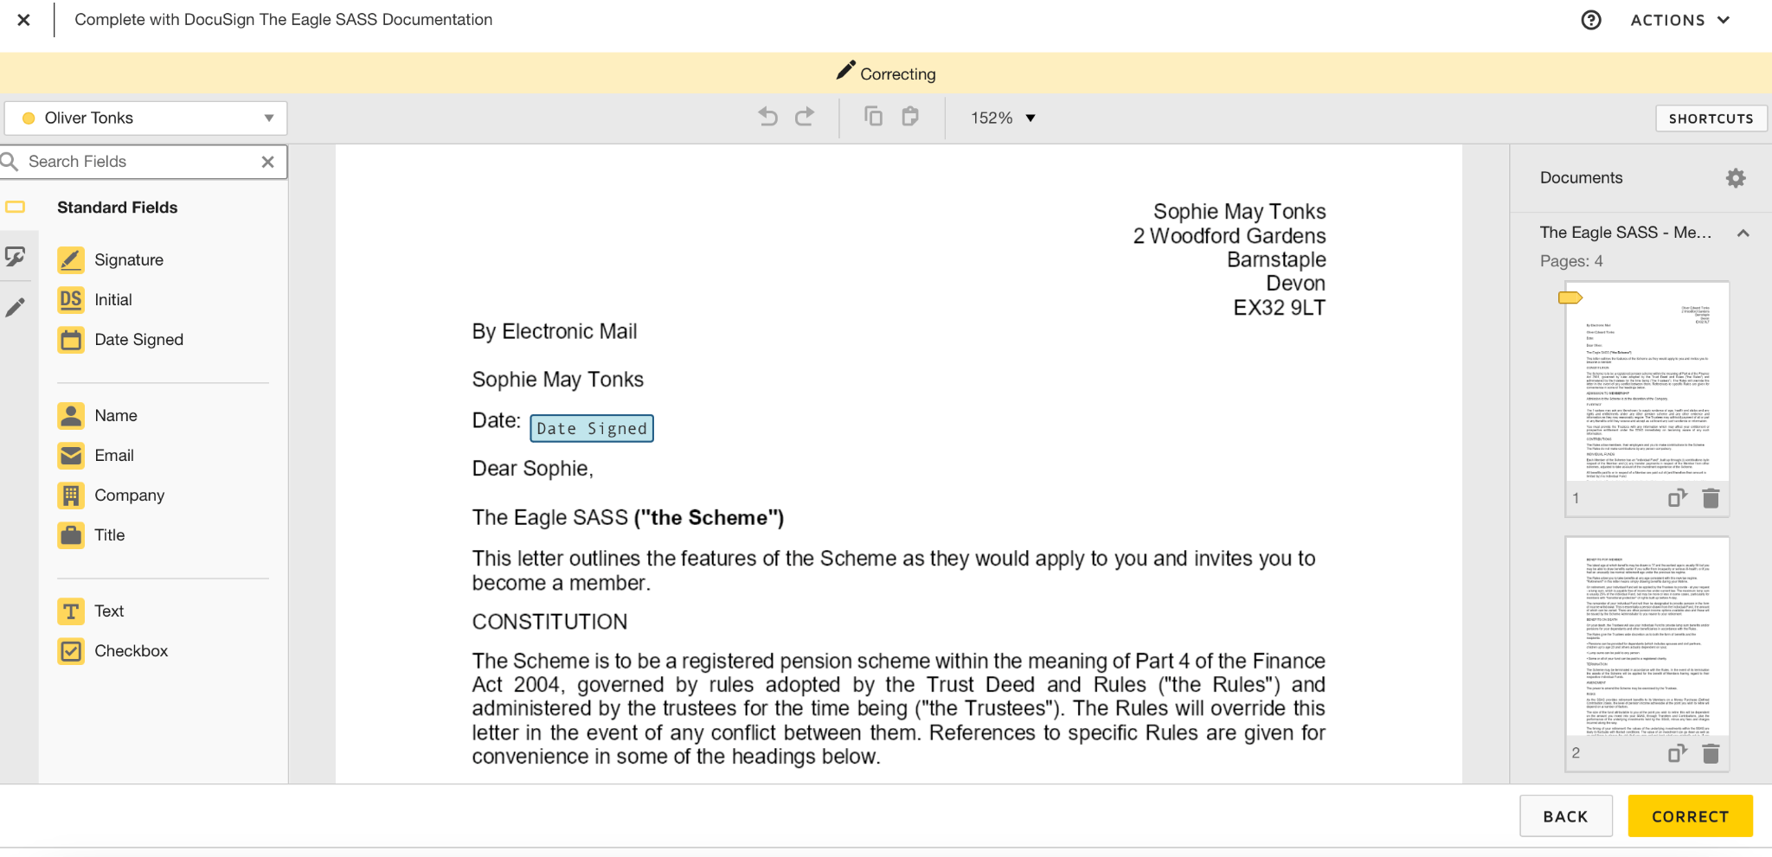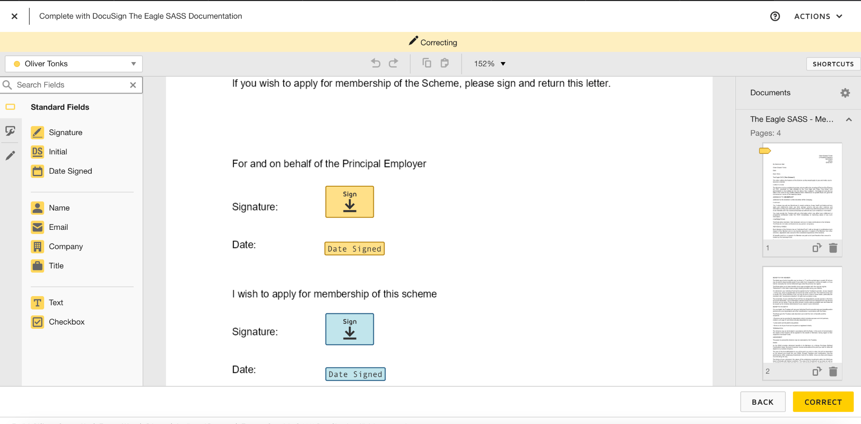

**Appointment of Admin**

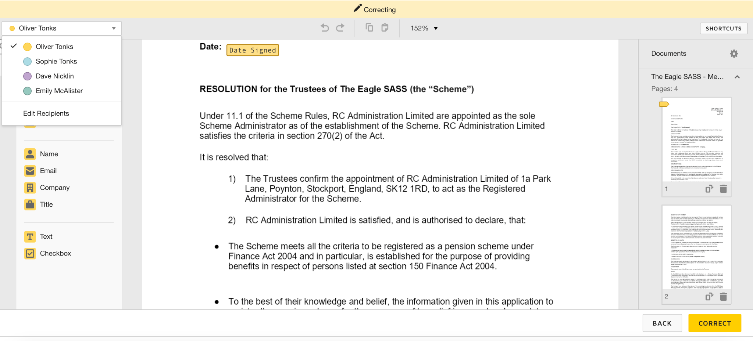

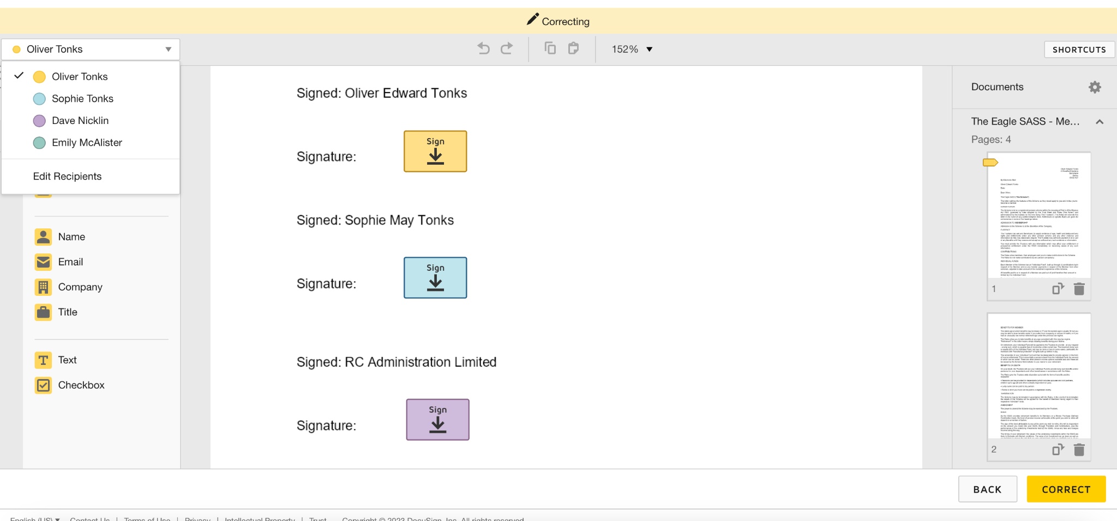

**Services Agreement**

