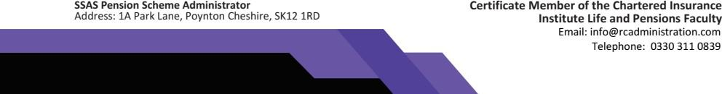

Kerr Stirling Solicitors Benview

10 Wellside Place Falkirk Stirlingshire FK11BB

FAO : Alison Nielson 14 July 2023

Dear Sirs,

Paul McMillan of the McMillan Trust

We act as registered administrator for the scheme known as McMillan Trust. RC Administration is also the registered administrator for the Retirement Capital platform, which is a pension administration platform for trustees of small self administered schemes.

The Trustees have placed an offer for land to be acquired by the Trust and this has been accepted for the sum of £168,000.

The Trust has no external borrowing requirements and this will be a cash purchase for the fund.

Would you please confirm that you are willing to act for the Trustees, being Paul McMillan and Alyson McMillan? I confirm that there is no corporate trustee.

Your disbursement costs associated with the purchase will be met by the Trust and we will provide you with the relevant documents in respect of the Trust and ML verification.

Finally, please note that all correspondence unless there are original documents of title, will always be sent by email and as such would ask you to use this method of communications with us.

Yours sincerely

G.A. McCloskey

**For RC Administration Limited**