*Insert Text About Retirement Capital*

Increase your wealth and save tax

We make building retirement capital enjoyable, secure and stress free.

We do this by combining an ethical approach, with technology and 1-1 personal assistant to make your SSAS a success story. We are on a journey to help business owners increase their wealth, reduce their tax bill, and make building retirement capital enjoyable, secure and stress free.

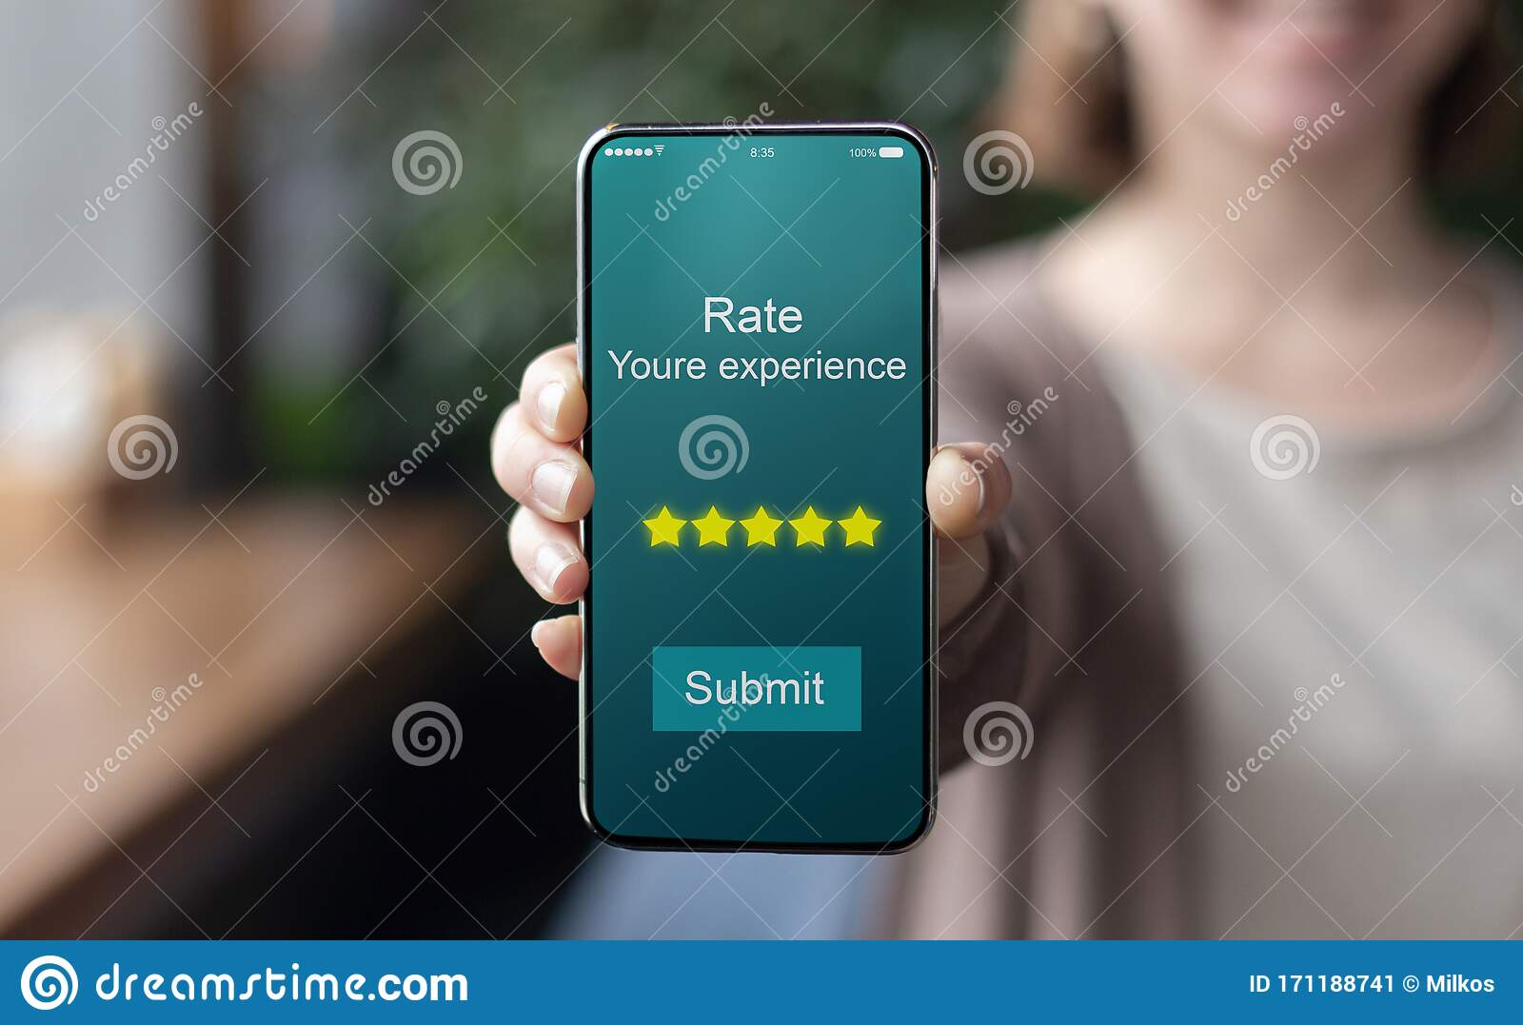

**Download The App for free**

The Retirement Capital app allows SSAS clients to access their pension and financial data in a smart, clear and secure way.

Retirement Capital is the UK’s first app developed solely for the small self-administered scheme customer. It’s core functionality allows customers to view and manage the entire cycle of their investment lifestyle via a smartphone and keep up to date with important milestones and events. The app syncs with your pension bank account, rental income, investment income and money transactions can all be managed through your app.

A big breakthrough is that whether you are paying in, taking money out or a bit of both, see your net worth now, in the future in any combination and how your money is performing for you. Access regulated financial advice through your smartphone and in two clicks, and speak with your personal assistant who administers your pension fund.

**Building your SSAS - as per website**

Use your SSAS pension to invest into property, or combine this with stocks, shares and investment in your business.

We will show you how to do this plus you have access to our FCA regulated advice services to help make the right choices.

You will achieve this with the Retirement Capital SSAS. Supported by us as your pension administrator we also keep your SSAS pension tax compliant throughout.

We have created a free resources library, plus we host every month guides and demonstrations on making your SSAS successful.

Our vision. To add rocket fuel to your retirement capital.

Welcome to Retirement Capital.

  # SSAS Experts

**Investments**

Find Out More

Please use Investment Choice from the website

**About Us Section**

**at the bottom of the website - please insert the following sub-section pages**

**Certified and Accredited**

Retirement Capital is certified and accredited for our services across all practice and affiliated company areas.

ISO certification certifies that our management, service and procedures have all the requirements for standardisation and quality assurance. ISO (International Organisation for Standardisation) is an independent, non-governmental, international organisation that develops standards to ensure the quality, trust, and efficiency of services, and systems.

Retirement Capital is one of the only SSAS providers in the UK that holds both certifications for financial management services.

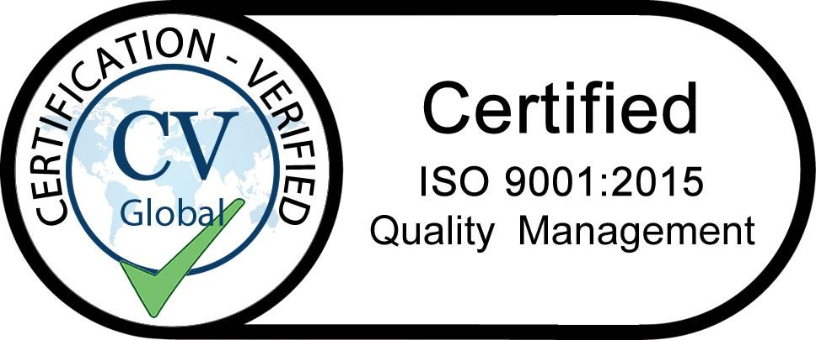

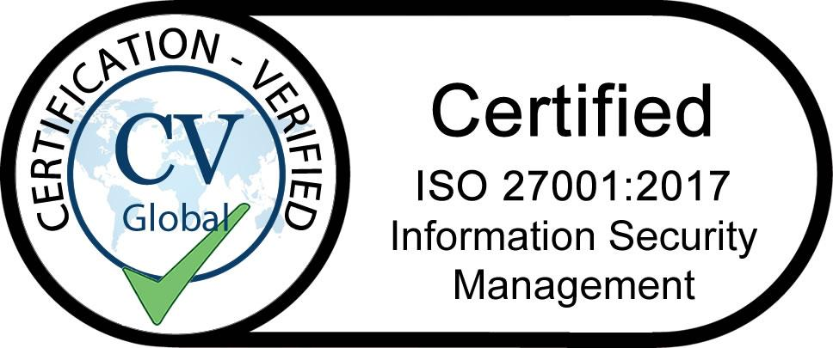

**HMRC Compliant**

RC Administration Limited (RCA) is a registered scheme administrator with HMRC and provides a fully compliant scheme administrator functionality for all HMRC reporting and compliance requirements. It trades under the Retirement Capital branding.

RCA is a recognised scheme administrator for the Retirement Capital platform, which is the UK's first technology led platform for SSAS trustees. All SSAS will be registered by RCA as scheme administrator and RC Administrated is connected into the platform.

RC Administration Limited registered office is situated at 1a Park Lane, Poynton, Stockport, SK12 1RD, CRN: 12409200

RCA is a member of the Association of Member Directed Schemes - AMPS359, which is the trade body for self directed pension schemes. RCA is fully ISO certified for Information Security Management and Quality Management.



**FCA Regulated for investment business**

It is important to take financial advice and expert guidance on suitable investments you intend to purchase through your SSAS. Also, we believe you should also take regulated financial advice on whether a SSAS is the right fit for you and your business. All customers of RC Administration Limited can access regulated financial services advice from RC Financial Services LLP and connect their investments into the Retirement Capital platform.

Investment business is undertaken by RC Financial Services LLP, which is an Appointed Representative of the ValidPath Ltd (FCA No. 197107), which is authorised and regulated by the Financial Conduct Authority.

RC Financial Services LLP is entered on the Financial Services register ([www.fca.org.uk/register](https://register.fca.org.uk/)) under reference number xxxxx.

RC Financial Services LLP registered office is situated at 18 Soho Square, London. W1D 3QL.

**Technology Focused Solution**

The Retirement Capital platform is powered by Amazon AWS and data is backed up on a continuous basis by SpinOne. SpinOne is a data protection platform that provides proactive ransomware monitoring, SaaS Apps risk assessment and access management, plus audit, backup, and recovery. Spin Technology is registered at 2100 Geng Road Suite 210, Palo Alto, California, USA, 94303.

The development and maintenance of platform technology via a customer relationship management software and applications are undertaken by the Practitioners LP, which is registered at the World Trade Centre, Gibraltar. GX11 1AA in conjunction with development teams in both South Africa, and India. Each customer has online connectivity to their SSAS account which sits through an excellent tie up with Amazon Web Services (AWS) on demand cloud computing platform, called the Retirement Capital platform.

AWS is the world’s leading provider of cloud computing and platform services. Our CRM systems are accredited via SSL certificates by DigiCert with the strongest encryption and highest authentication available.

DigiCert is the only provider of enterprise-grade SSL, IoT and PKI solutions. The world's top banks, and technology companies use Digicert to secure their digital properties and to protect the privacy and data integrity of consumers. We are pleased to announce that we are certified by Digicert and are Norton Certified for this solution.



Section on

**Success Stories**

Rochelle - please use the success stories from the website which are presently labelled case studies.

1. **Fred’s property portfolio just got bigger**

Fred the plumber case study

1. **Jas’s saves money every time she uses her SSAS**

Jas the contractor case study

1. **A baking success**

Jose and Maria case study

1. **An electrician’s sparkling idea**
2. **A smoother SSAS**

**Page at the bottom**

**We combat pension scams**

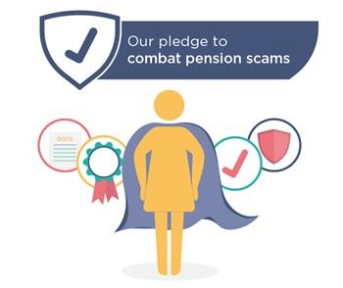

We are registered with the Pensions Regulator to do our bit to help our customers avoid pension scams. We adhered to the Industry Code of Conduct on Good Practice – a copy of which can be found [here](https://s3-eu-west-1.amazonaws.com/s3webfront/scam-practice.pdf). We also encourage customers to visit [Scam Smart](https://www.fca.org.uk/scamsmart), which gives information on pension and investment scams.

We have produced a brochure to help protect you and us, which also sets out our approach to investments and tax registration of your pension scheme. This and other information are contained for free in our resources library.

**Free Resources Guides**

1. *SSAS Guide*
2. *SSAS v SIPP*
3. *A technical guide*
4. *The role of the administrator*
5. *SSAS Success Stories*
6. *Transfer your old SSAS to Retirement Capital*
7. *Paying Money In*
8. *Taking Money Out*
9. *Investing your money*
10. *Transfer in other pensions*
11. *Commercial Property Investing*
12. *Borrowing and Mortgages*
13. *Your pension fund after you die*
14. *Loans to your business from your SSAS*
15. *Pension Scams*
16. *Residential Property - busting the myths*
17. *Pricing Menu*

**Pricing**

To set up a SSAS with Retirement Capital and look after all your paperwork and keep you fully compliant, we charge your business £100 per calendar month, or £89 per month after deduction of corporation tax at the small business rate.

This cost covers the day to day administration of the pension scheme, access to the Retirement Capital platform, online pension banking, unlimited mobile app and tablet devices, a dedicated personal administrator and full coverage of our insurance plan.

We are able to achieve these costs at lower than the industry rate, as we are built on [fintech](https://www.investopedia.com/terms/f/fintech.asp) from the ground up.

Family members can join for free with other beneficiaries.

We also offer other services, for which we will agree a fair fixed fee in advance, which are detailed below. You are not compelled to use us for these services.

· Legal advice and specialist services such as mortgage advice, lending, borrowing or arranging insurance on your property.

· FCA regulated investment advice

· FCA regulated pension transfer advice

· Help in transferring other pensions

· Full pension payroll (£30.00 per month)