Woodville Consultants Ltd

80 Lytham Road

Fulwood

Preston

Lancashire

PR2 3AQ

Standard Life

Standard Life House

30 Lothian Road

Edinburgh

EH1 2DH

13th December 2018

**Woodville SSAS**

**Mr Peter James Legge**

**Plan Number: WP1261662**

Dear Sirs,

Please find enclosed a signed Standard Life Transfer Out Application Form to fully transfer my benefits, together with:

1. Payslips x 3
2. P60
3. AIB Bank Statement for scheme account
4. HMRC Current Scheme Details
5. HMRC Tax Registration Letter
6. Trust Deed
7. Scheme Rules

I trust that you will find the enclosed complete and please do not hesitate to contact me should you have any further queries.

Yours Faithfully,

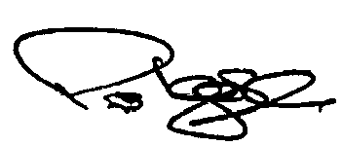

Woodville Consultants Ltd

Scheme Administrator