**Phoenix Life**

**PO Box 1243**

**Peterborough**

**PE2 2LD**

16th August 2023

Client name: **Susan Singleton**

Pension Company Policy/Plan Number: **0302937793/001**

As requested please find below the bank details for Singleton Family SSAS.

Account Name: SINGLETON FAMILY SSAS

Sass Account number: 45730719

Sort Code: 23-05-80

Metro Bank

One Southampton Row

WC1B 5HA

Yours Sincerely

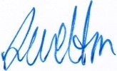

Lisa Welton

Scheme Administrator