

|  |  |  |  |
| --- | --- | --- | --- |
|  | Unity Bay D36 Limited | | |
|  |  |  | 1  0.5 Share |





Oakleaf Trustees Limited and Susan Savage as

trustees of the SavEnt Limited Executive Pension

Scheme both c/o registered office of 40 Kimbolton Road, Bedford, Bedfordshire, MK40 2NR

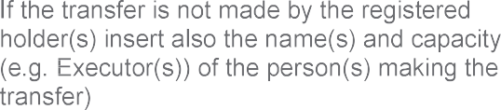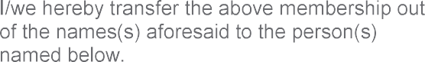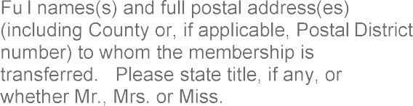

Susan Savage and Cranfords Trustees Limited

trustees of the SavEnt Limited Executive Pension

Scheme both c/o registered office of Cranfords

Trustees Limited, International House, Constance

Street, London, England, E16 2DQ

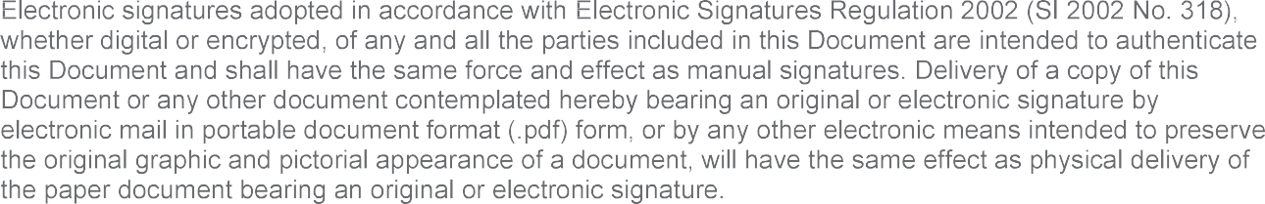

___________ Susan Savage

___________ /Cranfords Trustees Limited/