Our reference: Direct line: Email:

NWR/0041902/6777783 01737 230487

[networkrailpensions@willistowerswatson.com](mailto:networkrailpensions@willistowerswatson.com)

##### Private and confidential

Mrs M Sholanke 39 Liskeard Way Freshbrook Swindon Wiltshire

SN5 BNL

24 May 2023

**Hello Mrs M Sholanke, you've asked about transferring your benefits in the Network Rail DC Benefit scheme to Noble D Pensions,**

Before we can proceed with the transfer, please read the enclosed information leaflet which has been produced by the Government and the Financial Conduct Authority's online 'Scamsmart - Avoid investment and pension scams' information and guidance, which can be found at: https://[www.fca.orq.uk/scamsmart](http://www.fca.orq.uk/scamsmart)

Further information can also be found at <http://www.thepensionsregulator.qov.uk/pension>­ scams.aspx.

If you still wish to go ahead, please sign and return the enclosed member consent form. <We note that you have previously completed a 'member consent' form. However, since this form was issued to you, there has been a change in the law in respect of transfers, and a more comprehensive version has been created that must now be completed in order to proceed with your case.>

Upon reviewing your paperwork, we noticed that the member declaration form was received by Willis Towers Watson over **1** month after you signed it. You signed on 22 September 2022 and we received on 1 March 2023. As such, we are currently unable to proceed ahead with the transfer of your benefits. We require receipt of the form within 1 month from the date it is signed by you. Could you please counter sign the enclosed **Member declaration** form and return to us at your earliest convenience.

In addition, we noticed that transferring pension scheme name is missing on the Extra information sheet form. Could you please update **the 'Full name of the transferring pension scheme'** as **'Network Rail DC Pension Scheme'** and also counter sign the form as it is also received post 1 month after you signed it. Further a copy of this has been enclosed.

As an additional layer of protection against pension fraud, the trustees require you to undertake a short telephone consultation with the Willis Towers Watson ScamScan team in relation to your proposed transfer. The ScamScan team will contact you using the details you provide to hold the consultation, or to book a convenient time with you for the consultation.

Please note, the transfer cannot proceed until we have received your completed 'Member consent form' and the telephone consultation has been completed.

We recommend that you take impartial financial advice before deciding whether or not to transfer your benefits.

Please note that if you decide to go ahead with a transfer, your request may be passed to the trustees of the Plan for approval, which may result in a delay in processing your transfer.

### If you have any questions

Please contact the administrators of the Network Rail Pension Scheme by phone, or email, or via the [www.myNRpension.co.uk.](http://www.myNRpension.co.uk/) Please make sure you have your National Insurance number to hand for security identification purposes.

Call: 01737 230487

##### Email: [networkrailpensions@willistowerswatson.com](mailto:networkrailpensions@willistowerswatson.com)

Website: [www.myNRpension.co.uk](http://www.myNRpension.co.uk/)

Yours sincerely

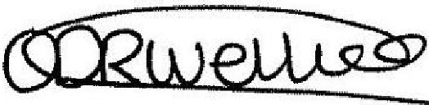"'

Oriana Weller

Enclosure:

### Network Rail DC Pension Scheme

Transfer out member consent form

This form should be completed for transfers to another UK pension plan/arrangement

**Member consent to transfer**



Name Mrs M Sholanke

Reference 0041902

number/Employee ID

|  |  |
| --- | --- |
| **Name of the transferring plan:** | Network Rail Defined Contribution Scheme |
| **Name of the receiving plan:** | Noble D Pensions |

|  |  |  |
| --- | --- | --- |
| **Your declaration** | | |
| I understand that **if** the transfer value payable to the receiving plan shown above is used to provide benefits in a form which is not 'authorised' in accordance with rules set out by HM Revenue & Customs this could result in significant tax charges. In particular, I confirm that:   * If I gain access either directly or indirectly to the transferred funds before the age of 55 (other than on the grounds of ill health), this payment will constitute an 'unauthorised payment' for tax purposes and I will declare **it** to HM Revenue & Customs and pay the tax due of up to   55%.   * I will protect and indemnify the Trustees of the transferring plan from any scheme sanction charge or other expenses that may arise as a result of making an 'unauthorised payment', if **it**   later transpires that the receiving plan does not meet the conditions required to be a registered pension scheme for tax purposes. | | |
| I will be taking benefits from the receiving plan before the age of 55 (other than on the grounds of ill health) | Yes **D** | No□ |
| If yes, was this subject to any particular conditions *(please provide details below)?* | | |
| I have read the FCA's 'Scamsmart' guidance and leaflet on pension scams and have understood the contents of this guide. | Yes **D** | No□ |
| I have taken impartial financial advice regarding this transfer. | Yes **D** | No□ |
| If I have taken financial advice, I have been provided with a written report detailing the new scheme, my attitude to risk and the investments that will be made on my behalf. | Yes **D** | No□ |
| If I have taken financial advice, the adviser seemed to be financially knowledgeable. | Yes **D** | No□ |
| I have discussed my attitude to risk with my adviser. | Yes **D** | No□ |
| It was explained to me that the value of pension investments can rise and fall. | Yes **D** | No□ |

|  |  |  |  |  |
| --- | --- | --- | --- | --- |
| I understand how my money is being invested. | | | Yes **D** | No□ |
| My chosen investment promises a guaranteed rate of return either now or at some point in the future. | | | Yes **D** | No□ |
| My chosen investments were selected from a list of funds offered by the receiving scheme. | | | Yes **D** | No□ |
| My chosen investment is purely based on purchasing property or land. | | | Yes **D** | No□ |
| My chosen investment is purely based on a single asset (e.g. a company)? | | | Yes **D** | No□ |
| If you have taken financial advice, please confirm the name, address and FCA registration number (if applicable) of your adviser: | | | | |
| Name of adviser: |  | | | |
| Address of adviser: |  | | | |
|  | | | |
|  | | | |
|  | | | |
|  |  | | |
| FCA registration number of adviser: | |  | | |
| Please confirm the name of the individual who recommended that you proceed with the transfer, the firm they work for, and the address of this firm: | | | | |
| Name of individual: |  | | | |
| Name of firm: |  | | | |
| Address of firm: |  | | | |
|  | | | |
|  | | | |
|  | |  |  |
| Is this firm authorised by the FCA to advise on pension transfers | | | Yes **D** | No□ |
| If yes, please confirm the firms FCA registration number | | | | |
| I have been asked to sign an insistent client document which confirms that I am not following my adviser's advice. | | | Yes **D** | No□ |
| There is more than one company involved in the advice to transfer my pension. | | | Yes **D** | No□ |

|  |  |  |  |  |
| --- | --- | --- | --- | --- |
| I am making offshore investments through the receiving scheme.  If yes, the potential risks were made clear to me in writing. | | Yes **D**  Yes **D** | | No□ No□ |
| Some or all of the investments are an offshore bond: | |  | Yes **D** Yes **D** Yes **D** Yes **D** Yes **D** | No□  No□ No□ No□ No□ |
| Some or all of the investments are listed on the FCA list of types of | |  |
| investment and pension scams: | |
| All the UK investments in the receiving scheme are regulated by the FCA. | |  |
| My investment is being made in a currency other than British Pounds. | |  |
| I have a separate investment company to manage my investments. | |  |
| If yes, please confirm the name and address of the company: | |
| Name of company: |  | | | |
| Where is the company based? |  | | | |
| Address of company: |  | | | |
|  | | | |
|  | | | |
|  | | | |
|  |  | |  |
| Is the company FCA registered? | | Yes **D** | | No□ |
| If yes, please confirm the firms FCA registration number | | | | |

|  |  |  |  |  |  |  |  |  |  |  |  |  |  |  |
| --- | --- | --- | --- | --- | --- | --- | --- | --- | --- | --- | --- | --- | --- | --- |
| I have been contacted 'out of the blue' about my pension transfer, either via a cold call, unsolicited email or text message, or offered a 'free pension review', or have been approached by an introducer outside of my place of work | | | | | | | | | Yes **D** | | | No□ | | |
| I will be receiving a cash payment, bonus, commission or loan from the receiving scheme or its administrators. | | | | | | | | | Yes **D** | | | No□ | | |
| I have been told that I will be able to draw more than 25% of my fund as a **tax-free** lump sum as a result of transferring. | | | | | | | | | Yes **D** | | | No□ | | |
| If yes, how much tax-free cash did the receiving scheme advise you could take? | | | | | | | | | £ | | | | | |
| If yes and the receiving scheme is a SSAS, please confirm the following information: | | | | | | | | | | | | | | |
| Name of receiving scheme practitioner/ administrator: | I | I | I | I | I | I | I | I | I | I | I I I | I I | I | I |
| I am a Trustee of the SSAS: | | | | | | | | | Yes **D** | | | No□ | | |

|  |  |  |  |  |  |  |  |  |  |  |  |  |  |  |  |  |  |  |  |  |  |  |  |  |  |  |  |  |  |  |  |  |  |  |  |  |  |  |
| --- | --- | --- | --- | --- | --- | --- | --- | --- | --- | --- | --- | --- | --- | --- | --- | --- | --- | --- | --- | --- | --- | --- | --- | --- | --- | --- | --- | --- | --- | --- | --- | --- | --- | --- | --- | --- | --- | --- |
| I was asked to set up my own company in order to make this transfer. | | | | | | | | | | | | | | | | | | | | | Yes **D** | | | | | | | | | | No□ | | | | | | | |
| If yes, the name of the company and my role in it is as follows: | | | | | | | | | | | | | | | | | | | | | | | | | | | | | | | | | | | | | | |
| Name of company: |  | I |  | I |  | I |  | I |  | I |  | I |  | I |  | I | I |  | I |  |  |  | I |  |  | I |  | I I | |  |  | I |  | I | I |  | I |  |
| Role: | I |  | I |  | I |  | I |  | I |  | I |  | I |  | I |  |  | I |  | I |  | I |  | I | I |  | I |  | | I | I |  | I |  |  | I | I |  |
| I have been given time limited offers, and was put under pressure to make quick decisions about this transfer: | | | | | | | | | | | | | | | | | | | | | Yes **D** | | | | | | | | | | No□ | | | | | | | |
| A courier was sent to collect any documents from me in relation to this transfer or the receiving scheme: | | | | | | | | | | | | | | | | | | | | | Yes **D** | | | | | | | | | | No□ | | | | | | | |
| I was provided with an illustration (also known as a quotation or key features document). | | | | | | | | | | | | | | | | | | | | | Yes **D** | | | | | | | | | | No□ | | | | | | | |
| I can confirm what the illustration said the below charges would be:  *(ff* a *charge is not applicable, please insert nla)*  My new scheme will charge me:  The investments selected will charge me: My adviser will charge me:  There will also be additional charges of: | | | | | | | | | | | | | | | | | | | | | Yes **D** | | | | | | | | | | No□ | | | | | | | |
| Initial charges | | | | | | | | | | Annual charges | | | | | | | |
| £ | | | | | | | | % | | £ | | | | | | % | |
|  | | | | | | | |  | |  | | | | | |  | |
| My pension will always be easy to get to without additional charges if I wanted to move it or access it in the future. | | | | | | | | | | | | | | | | | | | | | Yes **D** | | | | | | | | | | No□ | | | | | | | |

|  |  |  |
| --- | --- | --- |
| Transfer requests to the receiving plan have been refused by the provider or  Trustees for other pension plans I have with other providers or Yes **D** No□ administrators?  If yes, do you know why *(please provide details)?* | | |
|  | | |
|  | | |
|  | | |
| I completed this questionnaire myself.  If I did not complete this questionnaire myself, I **fully** understand and agree with the responses given. | Yes **D**  Yes **D** | No□  No□ |

**Can you briefly explain your reason(s) for requesting the transfer? What will you be able to achieve by transferring that you will not be able to do in your existing plan?**

|  |  |  |  |  |  |
| --- | --- | --- | --- | --- | --- |
|  | | | | | |
| **In addition, for transfers to occupational pension schemes only:**  I am a member of the receiving plan and am employed by and receive relevant earnings from the sponsoring employer, which is: | | | | | |
| Employer name: |  | | | | |
| Employer address: |  | | | | |
|  | | | | |
|  | | | | |
|  | | | | |
| Business, service or trade of employer: |  | | | | |
|  | | | | |
|  | | |  |  |
| Is your employer (named above) actively trading? | | | | Yes **D** | No□ |
| **Signed** |  | **Date** |  | | |

I Print name I I I I I I I I I I I I I I I I I I I

N two.rk.R II D n di Contri ··on1P n on Sch m (NRDC)

# Your transfer agreem,ent

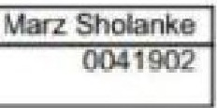

iP _,rt two-ycn.1r identity eh ck

I: **ft ngmblr**I

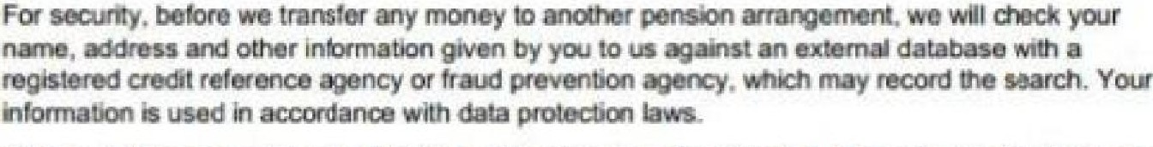

TII

no

our d n lty **nd rtd** ·

**.11-Asasecoodc!'leck.**

**w** I

IU, **p/'lo! pa$$**

P1 kr'low on 01737

Your identity check

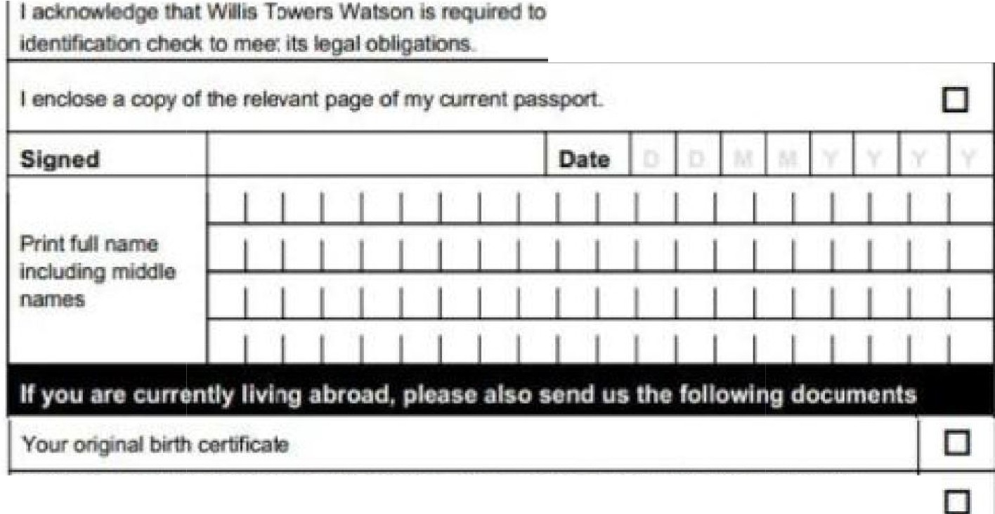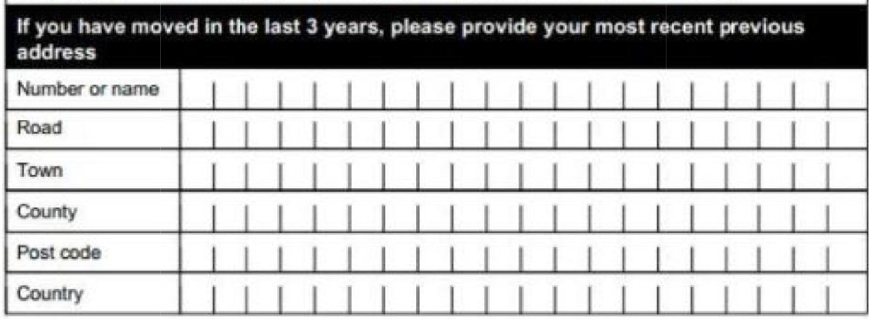

**OUI MICIJ**

□

2 angina

doc, .

**do not** hav11 2 utfity **bllls,'Wt!** aa:e,pl

**hill. l]hnr,R-**t,ill nir H Rr. hn nr,i11)

*n,aJITJmtNN/ you .sand your birtht:flni lfl* 1M*II arlrat;ked def"NPNY SIIMC!I.*

#### twor,k Rall D fin d Conlribut O'n IP n 'on Sch m (NRDC)

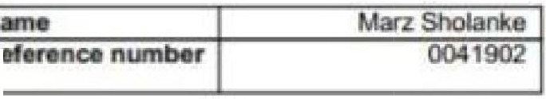Your transfer agreement

1:

## P rt hre ·. - you,r duel r: lion

Your transfer confirmation continued

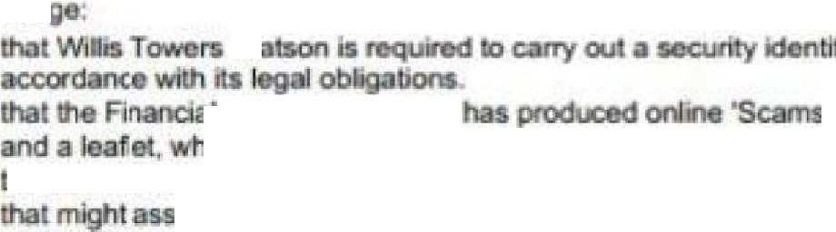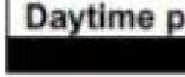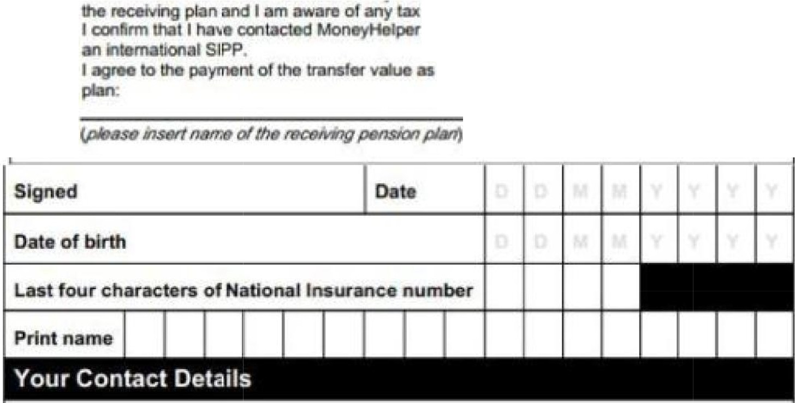

**By**

I •--""

farm.

I I

Scheme.

lacllncNiltea

0

10,tna oona tiOn out in one - )IOUr con non· *al'* rn11,

,.,

**me decide**

r from,

, •

**0**

w

I

**Con<luel.Aulhcrily**

tlcn et, ck k-1

mart' QU.ldance

iclil I · **oodemood.**

o ·

- .

. s Regulator **and MoneyH._ issue** i"lklmlation a

rr

sfe .

QmB.

f

**.-,1'119lDII' in c:11:::.**

,,.,

**i**

**.**

**S.,.l!Qal'KIII**

..

my ill!IJ tlli:rTw:ints !n

Jv p **nll**

**above to allowing** n110n

Entilll

hone number

#### , your *t* . _ n on four, overie r.

e tum thla form to: an P nslon Sdwm,1 RDC 



Pensnri•s .PO So:c 54S, R

# Extra information form

In order for the trustees to assess your transfer against the conditions set out in the Transfer Regulation, please complete and return this form along with your transfer forms.

|  |  |  |
| --- | --- | --- |
| **Member Details** | | |
| Member's full name: | |  |
| Full name of the transferring pension scheme: | |  |
| Member's Reference number or Employee·ID in the transferring scheme (as shown on your transfer paperwork): | |  |
| Full name of the receirving pension scheme: | | Nao |
| Is the receivlng scheme an occupational pension scheme? | | Yeso  □ |
| Is the receiving soheme a Qualifying Recognised Overseas Pension Scheme? | | Yeso No |
| Name of | financial adviser (if applicable) | |

I

## I FCA reference number of adviser (if applicable)

Signed



I Print name

Date