Paul Spence

100 North Hill

London

N6 4RL

HM Revenue and Customs

Pension Schemes Services

BX9 1GH

FAO John Bhandal

25th September 2019

Dear John,

SRN: S0000002416

Scheme: Medville Properties Ltd Pension Scheme

I refer to your letter dated 13th September 2019 in connection with the registration of this scheme.

I am a ‘fit and proper person’ to act as a scheme administrator. I am aware of the duties involved which are published and clearly explained on your website, including the returns process which I have declared to adhere to and fulfil.

If there are any requirements where I am unsure then I will appoint a firm to assist me where required. However, the only investment I intend to make at this point will be through a regulated financial adviser. The value of my fund will be less than £400,000 in the first year with no connected party transactions. This makes the scheme tax reporting very straightforward.

My intentions are to use my scheme to invest into property at some point in the future and at that juncture additional advice may be needed. Whilst I will consider such an appointment, this does not replace or delegate my ability to act as a trustee /administrator. Furthermore, my financial adviser Ron Treherne IFA Ltd FCA No 521950 will be steering my financial advice decisions and he will be remunerated directly through fees charged on any investments I decide to make.

I have not agreed a fund choice or investment manager at this stage but will be considering this at a future date.

I trust this clarifies the position.

Yours faithfully

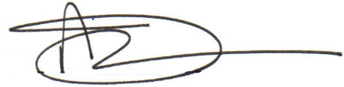

Paul Spence

Trustee / Scheme Administrator