Paul Spence

100 North Hill

London

N6 4RL

HMRC

Pension Schemes Services

BX9 1GH

11th June 2019

Dear Sirs,

SRN: S0000001759

Scheme: Medville Properties Limited Pension Scheme

I refer to your letter dated 31 May 2019 in connection with the registration of this scheme. I have provided clarification below.

I am a ‘fit and proper person’ to act as a scheme administrator. I am aware of the duties involved which are published and clearly explained on your website, including the returns process which I have declared to adhere to and fulfil.

If there are any requirements where I am unsure then I will appoint a firm to assist me where required. However, the only investment I intend to make at this point will be through a regulated financial adviser. The value of my fund will be less than £400,000 in the first year with no connected party transactions. This makes the scheme tax reporting very straightforward.

I do intend to use my SSAS to invest into property at some point in the future and at that juncture additional advice may be needed. Whilst I will consider such an appointment, this does not replace or delegate my ability to act as a trustee /administrator. Furthermore, my financial adviser Ron Treherne IFA Ltd FCA No 521950 will be steering my financial advice decisions and he will be remunerated directly through fees charged on any investments I decide to make.

I have not agreed a fund choice or investment manager at this stage but will be considering this at a future date.

I trust this clarifies the position.

Yours faithfully

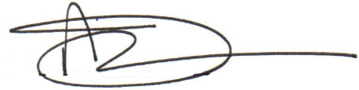

Paul Spence

Trustee / Administrator