

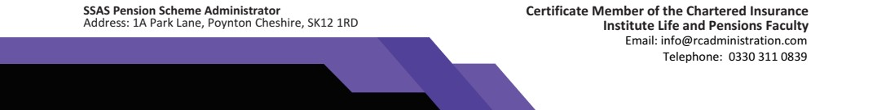

The Trustees of the ML & S Lynch SSAS
Wessex House
Drake Avenue
Staines-upon-Thames
Middlesex
TW18 2AP

23 February 2022

Member: Jennifer Irene Lynch
Dear Sir/ Madam,
We have received a draft of a Pension Sharing Order for the above-named member, under which a transfer of pension credit to the member’s pension fund held in the Jenspot SSAS is ordered.

Please be advised that after reviewing this information we willing, and the Trustees have authorised us, to accept the transfer of pension credit to the Jenspot SSAS and are in a position to implement the content of this order. We now await further instruction from you.

If you require any further information, please call us on 0330 311 0088.
Yours sincerely,
Emily McAlister

For RC Administration Ltd

Scheme Administrator for the Jenspot SSAS

