Royal London

5th Floor

Churchgate House

56 Oxford Street

Manchester M1 6EU

21st March 2022

Via email and post: pensiontransfers@royallondon.com

**Plan: 8216160**

**Personal Pension Scheme**

**Plan Holder Name: Liza Harrison**

To Whom it May Concern,

Further to your letter dated 17th January 2022 addressed to Liza Harrison, please accept this letter as confirmation that Liza wishes to transfer her funds to her pension scheme LCH Cleaning Ltd SSAS, PSTR 20005737RJ, tax registered 25/02/2022.

Please find enclosed completed:

1. Completed Transfer Out Form
2. Scheme Trust Deed and Rules
3. HMRC Tax Registration letter
4. HMRC Screen Shot
5. Contribution to scheme Letter
6. Copy of Passport
7. Copy of Utility Bill

We would be grateful if you may process Liza’s request at your earliest convenience to her pension scheme bank:

Account Name: LCH Cleaning Ltd SSAS

Bank: Metro Bank

Account Number: to follow

Sort Code: to follow

Should you have any queries, or require any further information, please do not hesitate to contact us.

Yours Faithfully,

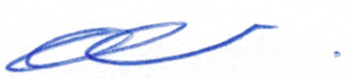

Esther Salmon

Scheme Administrator