# Hutchinson Pension Scheme 2nd Generation

**Trustee Report 2018**



**Index**

1. Introduction
2. Fund Composition
3. Scheme Tax Return
4. New Platform
5. Benefits Statements
6. Data Protection Changes
7. **Introduction**

I am pleased to enclose our annual trustee report for your scheme.

We have prepared benefit statement for each of you and can of course tailor this according to your needs and planning requirements. I have excluded the crystallised rights for Derek as under flexible access there is no restriction on the amount of funds payable from the scheme.

In the autumn of 2018 we are launching a new online platform, which is intended to help you get value for money, and build retirement capital via Fintech. This is the first of it’s kind for the UK market for SSAS clients and it has taken us a number of years to develop. We hope that this will be of benefit to you. You can of course opt out of this online service, and keep everything as it is. I will contact you separately on this following this report.

I would also like to thank you for choosing us to act as the Practitioner for your pension scheme.

# Fund Composition

The income generated is equivalent to 4.74% net yield to the Scheme.

# Scheme Tax Return and Reporting

Below is a copy of our tax report submission for the period ending 5 April 2018 and our supporting comments.

The scheme reporting is one of the most important aspects of scheme management as the data submitted may be reviewed by an Inspector in connection with scheme fund movements. It is particularly important that where transactions are undertaken which may involve the scheme connected to persons or businesses associated with either the scheme members or the employer that we report that information in the correct format.

It is important that clients notify us in advance of any transactions involving either a scheme member, a close connected company or someone connected to a scheme member, such as a relative or business partner.

The following data has been submitted;

**Details**

|  |  |  |
| --- | --- | --- |
| Pension Scheme Tax Reference |  | 00738501RH |
| Pension Scheme Name |  | Hutchinson Pension Fund Second Generation |
| Is the scheme an Occupational scheme? |  | Yes |
| Tax Year ended |  | 05 Apr 2018 |
| Date submitted |  | 06 Jan 2019 |
| Submitted by |  | The Practitioners Partnership LP |
| Scheme Administrator |  | equip4work limited |
| Amended Return |  | No |

|  |  |  |
| --- | --- | --- |
| Accounting Period |  | 06 Apr 2017 - 05 Apr 2018 |
| During this period, was the aggregate of payments to and from the scheme greater than £100,000? |  | No |
| Specify the aggregate of payments to and from the scheme |  | £14821 |

|  |  |  |
| --- | --- | --- |
| At the end of this period, did the scheme have assets with a total value before pension liabilities greater than £400,000? |  | Yes |

**Connected Parties**

|  |  |  |
| --- | --- | --- |
| At any time during the period from 06/04/2017 to 05/04/2018 did the scheme either directly or indirectly own assets that it had acquired from either: a. a sponsoring employer or any person connected with that employer? *or* b. a person who was a director of or a person connected to a director of a close company that was also a sponsoring employer? *or* c. a person who was either a sole owner or partner or a person connected with the sole owner or partner of a business which was a sponsoring employer? *or* d. a member or person connected with a member? |  | No |

**Cash and Bank Information**

|  |  |  |
| --- | --- | --- |
| Total amount of all cash and bank balances at the beginning of the period |  | £1307739 |
| Total amount of all cash and bank balances at the end of the period |  | £1474632 |
| Total amount of interest credited to these accounts |  | £1884 |

**Arms Length Transactions**

|  |  |  |
| --- | --- | --- |
| Total cost or market value of any assets owned at the end of the period Specify whether this amount is |  | £2112670  Market value |

|  |  |  |
| --- | --- | --- |
| Total amount of income from assets received |  | £168186 |

There were no activities to report which fell under AFT reporting – which are summarised as:

|  |  |
| --- | --- |
| **Payment** | **When the charge applies** |
| Short service refund lump sum charge | Payable when the scheme refunds contributions to a member who was a member for less than 2 years. |
| Lifetime allowance charge | This tax is due when the scheme pays a pension to a member and they’ve used up their lifetime allowance. |
| Special lump sum death benefit charge | A 45% tax due if the scheme pays certain sums |
| Serious ill-health lump sum charge | From 16 September 2016 the serious ill-health lump sum payment is treated as taxable income and will form part of the Real Time Information (RTI) reporting that pension scheme administrators have to do. |
| Authorised surplus payments charge | A 35% tax that is due if the scheme pays surplus scheme funds to an employer. |
| De-registration charge | A tax charge of 40% of the pension scheme value if HMRC removes the tax registration of the pension scheme. |
| Annual allowance charge | Where the member has given the scheme administrator a notice requiring them to pay the tax for the member. |
| Overseas transfer charge | A tax charge of 25% on taxable overseas transfers made from 9 March 2017. |

**Arms Length Transactions**

Arms length transactions is any person, body or firm that falls outside of the connected part definition given above. It is possible to change from connected party to arms length and vice versa. If you are unsure of the arms length status of the scheme’s holdings please let us know.

The arms length holdings were submitted as property and cash at bank. There were no event reports arising in the scheme year which are updated as:

|  |  |
| --- | --- |
| **Event report number** | **Details of events to be reported** |
| 1 | The scheme made or is treated as having made an unauthorised payment. |
| 2 | Payments of lump sum death benefit(s) of more than 50% of the lifetime allowance. |
| 3 | Payment of benefits to a member under age 55 who is a scheme employer, director of a scheme employer (or associated company) or connected to such a person. |
| 4 | Payment of a serious ill-health lump sum to a member who is a scheme employer, director of a scheme employer (or associated company) or connected to such a person. |
| 5 | The scheme stops paying out an ill-health pension. |
| 6 | A member’s benefits are tested against the lifetime allowance (a benefit crystallisation event) and:   * they have an enhanced lifetime allowance, enhanced protection, fixed protection, fixed protection 2014 or individual protection 2014 * their total benefits are more than the lifetime allowance   The Event Report does not currently include fixed protection 2016 (FP2016) and individual protection 2016 (IP2016), so you will not be able to use the 2016 to 2017 or 2017 to 2018 Event Reports to report reference numbers of your members relying on FP2016 or IP2016 from 6 April 2016.  If your members have relied on fixed protection 2016 or individual protection 2016. |
| 7 | Payment of a pension commencement lump sum which is both:   * more than 25% of the member’s pension pot * between 7.5% and 25% of the lifetime allowance |
| 8 | Payment of a pension commencement lump sum to a member with primary or enhanced protection, and the lump sum is more than the maximum lump sum payable to a member without lump sum protection. |

|  |  |
| --- | --- |
| **Event report number** | **Details of events to be reported** |
| 8A | Payment of a stand-alone lump sum (100% lump sum) and the member had either:   * protected lump sum rights of more than £375,000 with either primary protection or enhanced protection * scheme specific lump sum protection and the lump sum is more than 7.5% of the lifetime allowance |
| 9 | A transfer to a qualifying recognised overseas pension scheme (QROPS) where the transfer was requested before 6 April 2012. |
| 10 | The scheme becomes or stops being an investment regulated pension scheme. |
| 11 | The scheme changes its rules to either:   * require the scheme to make an unauthorised payment * allow the scheme to have investments other than insurance policies |
| 12 | A scheme treated as 2 schemes by HMRC before 6 April 2006 changes any of its rules. |
| 13 | The scheme’s structure changes. |
| 14 | The number of members at the end of the tax year has changed band compared to the band at the end of the previous tax year. The bands are:   * 1 member * 2 to 11 members * 12 to 50 members * 51 to 10,000 members * more than 10,000 members |
| 18 | The scheme administrator is subject to a scheme sanction charge because of investment in taxable property. |
| 19 | The scheme changes its country of establishment. |
| 20 | The scheme becomes or stops being an occupational pension scheme. |
| 20A | The scheme becomes or stops being a Master Trust scheme. This must be reported within 30 days of this event. |
| 21 | Either a member or dependant moves into flexible drawdown - tax years 2012 to 2013, 2013 to 2014 and 2014 to 2015 only. |

|  |  |
| --- | --- |
| **Event report number** | **Details of events to be reported** |
| 22 | The scheme administrator has automatically issued a ‘standard’ pension savings statement |
| 23 | The scheme administrator has automatically issued a ‘money purchase’ pension savings statement |

# Online Platform

We have developed a new online platform for you. This will allow you to manage your SSAS. We have called this platform, Retirement Capital. Each member of the scheme will be able to login and access their own account and fund share via our new platform aptly named: retirement.capital. Each scheme member will have their own login and password, each share of fund will be held.

We are launching the platform in two phases.

Phase 1 is available in autumn 2018 and it will provide you with helpful information including:

1. Contribute (your available annual allowance will automatically be updated)
2. Take pension benefits – you can set up pension and lump sum instructions via your dashboard.
3. Invest into your business – this can be set up as a pension scheme loan.
4. Secure the best deposit rates for your SSAS – the latest rates of deposit accounts are available.
5. View and change your beneficiaries
6. See an immediate forecast of your benefits, with lump sum and pension income.
7. A nice pie chart of your holdings
8. Immediate cash value of your pension account (for AIB accounts)
9. Valuation of other assets
10. Online support and live chat
11. Tax reporting and scheme management

Phase 2 will build on these key functionalities and will include online bank instructions to us, property management functionality, online document and statement storage, investment management development through a single dashboard. We will also build on a retirement and phased income calculation tools. Phase 2 will be ready in the first quarter of 2019.

Integrated share trading and dealing will be delivered in the third and final phase.

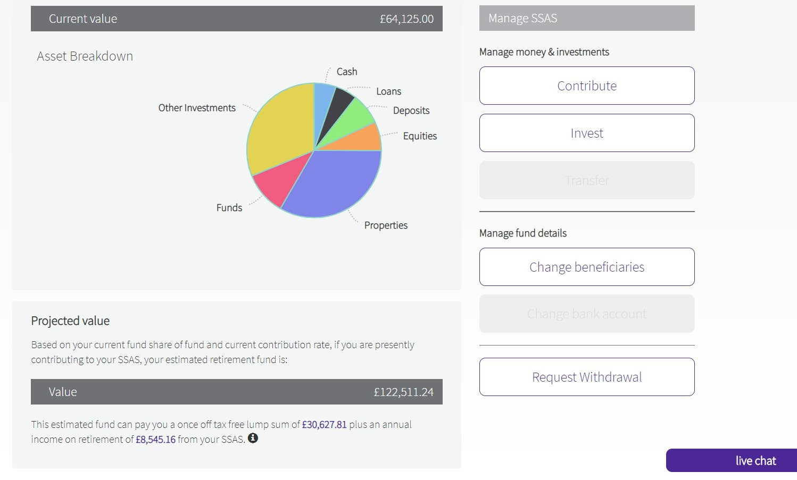Certain investments can be integrated onto your dashboard, this includes funds managed by your financial advisor which offer an API feed. Below is a snap shot of how your account could look:

Your investments are broken down with online functionality that will appear like this. The tabs allow you to undertake certain instructions.

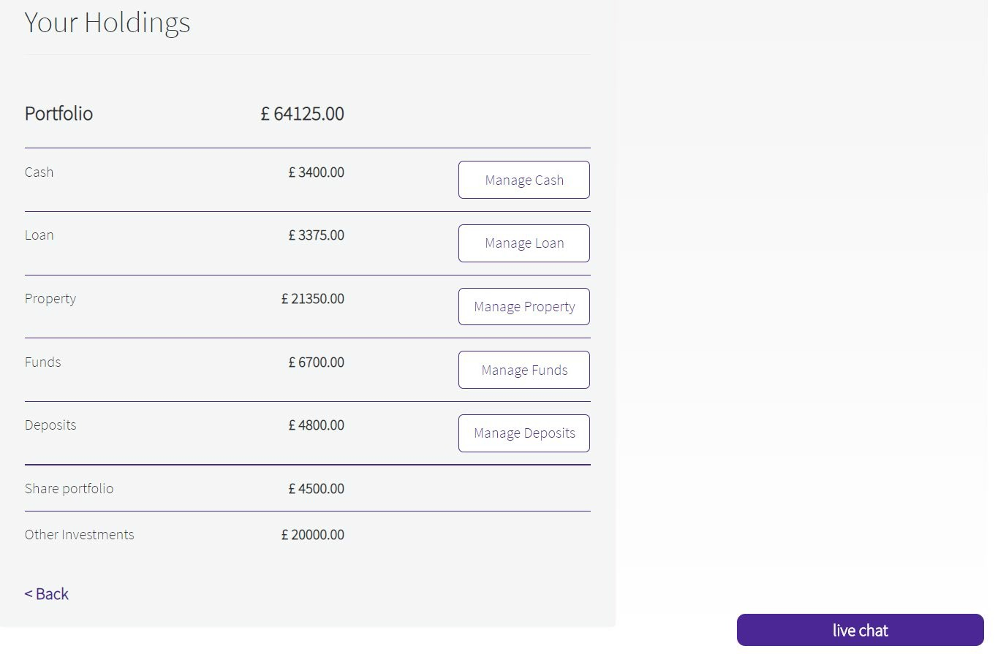

You can make a number of investments from your cash account. Investment funds can be linked into your financial advisor. We will organise this with them once we activate your online account. We also offer an “in field” search functionality for commercial property with Zoopla.

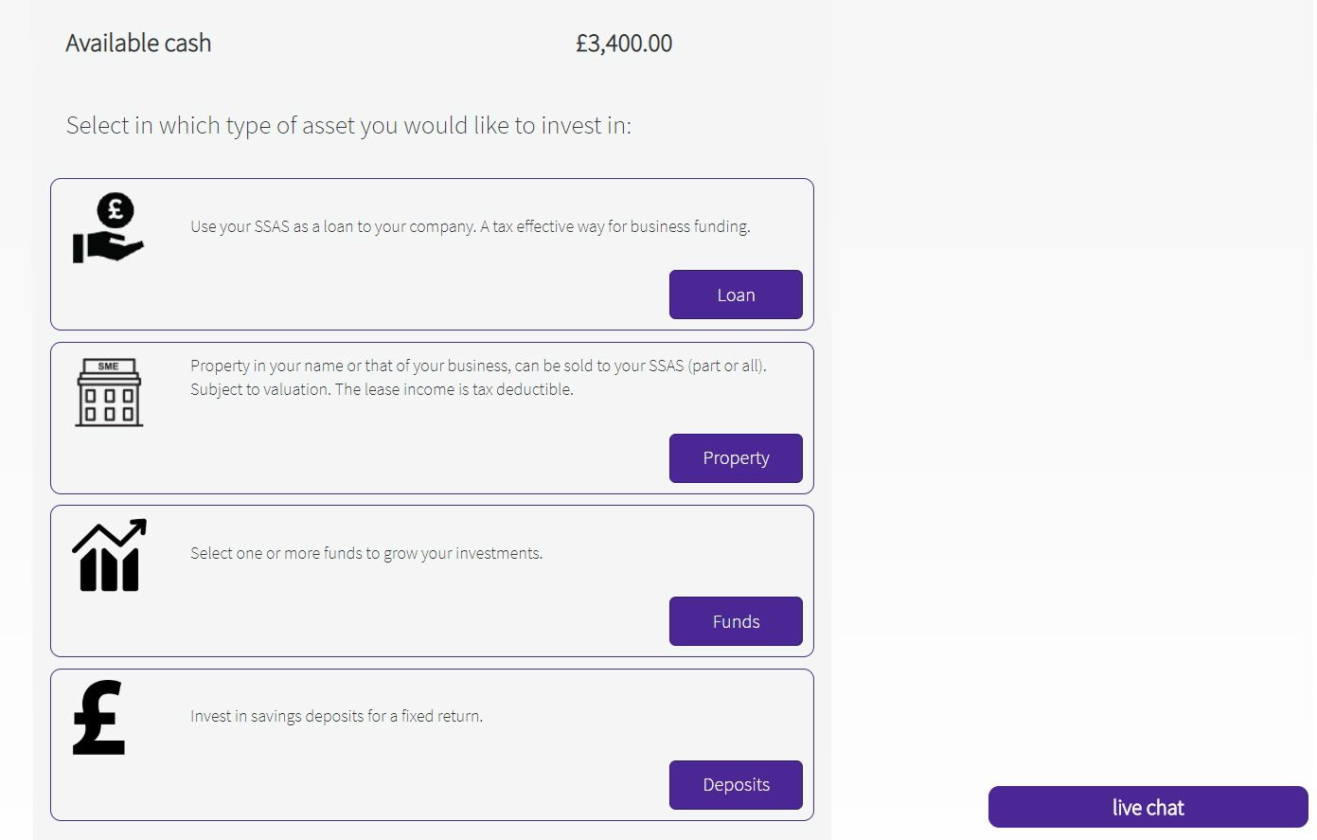

We are also introducing an integration property management tool and accountancy software following our tie in with Xero software. Quite simply it will allow integration of property management to take place, reflecting expenditure, accounting and also property leases, documents etc..

# 5. Benefit Statements

**Benefit Statement for Derek – Uncystallised Fund**

|  |  |
| --- | --- |
| Estimated Retirement Fund at age 75: | £806,000 |
| Tax Free Cash Sum: | £201,500 |
| Pension Income: | £42,100 |
| Estimated Retirement Date: 75 |  |

We have made the following assumptions:

1. Investment growth is a net rate of 5%
2. Inflation is 2.5% p.a.
3. Pension will not increase in retirement.
4. All figures take account of inflation at an assumed rate of 2.5% p.a.
5. The estimated annual retirement income is based on current annuity rates.
6. No provision has been made for additional contributions.

The figures are a guide and not guaranteed. Your final pension fund and the income available will depend on factors including the growth your fund achieves, contributions you make in future, charges, inflation, your retirement age, annuity rates at the time and the annuity or drawdown options you choose.

**Benefit Statement for Hayley**

|  |  |
| --- | --- |
| Estimated Retirement Fund at age 65: | £659,000 |
| Tax Free Cash Sum: | £164,750 |
| Pension Income:  Estimated Retirement Date: 65 | £22,200 |

We have made the following assumptions:

1. Investment growth is a net rate of 5%
2. Inflation is 2.5% p.a.
3. Pension will not increase in retirement.
4. All figures take account of inflation at an assumed rate of 2.5% p.a.
5. The estimated annual retirement income is based on current annuity rates.
6. No provision has been made for additional contributions.

The figures are a guide and not guaranteed. Your final pension fund and the income available will depend on factors including the growth your fund achieves, contributions you make in future, charges, inflation, your retirement age, annuity rates at the time and the annuity or drawdown options you choose.

**Benefit Statement for Martin**

|  |  |
| --- | --- |
| Estimated Retirement Fund at age 65: | £580,000 |
| Tax Free Cash Sum: | £145,000 |
| Pension Income: | £19800 |
| Estimated Retirement Date: 65 |  |

We have made the following assumptions:

1. Investment growth is a net rate of 5%
2. Inflation is 2.5% p.a.
3. Pension will not increase in retirement.
4. All figures take account of inflation at an assumed rate of 2.5% p.a.
5. The estimated annual retirement income is based on current annuity rates.
6. No provision has been made for additional contributions.

The figures are a guide and not guaranteed. Your final pension fund and the income available will depend on factors including the growth your fund achieves, contributions you make in future, charges, inflation, your retirement age, annuity rates at the time and the annuity or drawdown options you choose.

**Benefit Statement for Carole**

|  |  |
| --- | --- |
| Estimated Retirement Fund at age 75: | £404,000 |
| Tax Free Cash Sum: | £101,000 |
| Pension Income:  Estimated Retirement Date: 75 | £21100 |

We have made the following assumptions:

1. Investment growth is a net rate of 5%
2. Inflation is 2.5% p.a.
3. Pension will not increase in retirement.
4. All figures take account of inflation at an assumed rate of 2.5% p.a.
5. The estimated annual retirement income is based on current annuity rates.
6. No provision has been made for additional contributions.

The figures are a guide and not guaranteed. Your final pension fund and the income available will depend on factors including the growth your fund achieves, contributions you make in future, charges, inflation, your retirement age, annuity rates at the time and the annuity or drawdown options you choose.

.

**Benefit Statement for Michael**

|  |  |
| --- | --- |
| Estimated Retirement Fund at age 65: | £675,000 |
| Tax Free Cash Sum: | £168,750 |
| Pension Income:  Estimated Retirement Date: 65 | £22,700 |

We have made the following assumptions:

1. Investment growth is a net rate of 5%
2. Inflation is 2.5% p.a.
3. Pension will not increase in retirement.
4. All figures take account of inflation at an assumed rate of 2.5% p.a.
5. The estimated annual retirement income is based on current annuity rates.
6. No provision has been made for additional contributions.

The figures are a guide and not guaranteed. Your final pension fund and the income available will depend on factors including the growth your fund achieves, contributions you make in future, charges, inflation, your retirement age, annuity rates at the time and the annuity or drawdown options you choose.

**Benefit Statement for Emma**

|  |  |
| --- | --- |
| Estimated Retirement Fund at age 65: | £147,000 |
| Tax Free Cash Sum: | £36600 |
| Pension Income:  Estimated Retirement Date: 65 | £5030 |

We have made the following assumptions:

1. Investment growth is a net rate of 5%
2. Inflation is 2.5% p.a.
3. Pension will not increase in retirement.
4. All figures take account of inflation at an assumed rate of 2.5% p.a.
5. The estimated annual retirement income is based on current annuity rates.
6. No provision has been made for additional contributions.

The figures are a guide and not guaranteed. Your final pension fund and the income available will depend on factors including the growth your fund achieves, contributions you make in future, charges, inflation, your retirement age, annuity rates at the time and the annuity or drawdown options you choose.

# 6. Data Protection Act Changes

The **General Data Protection Regulation** (**GDPR**) is a regulation intended to strengthen and unify data protection for all individuals within the European Union.

It is effective on 25 May 2018 and replaces the data protection act. It is the biggest shake up in generations to data use, privacy and business impact. It covers anyone who is engaged in data use and storage.

Small self administered schemes have a unique relationship in that the employer sponsoring the scheme, the members and trustees are connected. Your scheme will be affected by GDPR, because of the different bodies that exist in respect of the scheme.. To assist, you will shortly receive a resolution from us to be appointed to handle much of the new requirements of GDPR in respect of your scheme.

If the sponsoring employer is a trading company and holds personal data it will be affected by the regulations and as such, our GDRP service can by extension help your business comply.

*‘Personal Data’ means any information relating to an identified or identifiable natural person (‘data subject’); an identifiable natural person is one who can be identified, directly or indirectly, in particular by reference to an identifier such as a name, an identification number, location data, an online identifier or to one or more factors specific to the physical, physiological, genetic, mental, economic, cultural or social identity of that natural person. It is all encompassing.*