2013 Annual Report

to the Trustees of

**Hammerhead TV Pension**

**Scheme No 1**

**Index**

**1.** Introduction

**2.** Pension scheme return

**3.** Inflation report 2013 and outlook for 2014

**4.** Economic and markets report

**5.** Latest news

**1. Introduction**

We are pleased to enclose our annual report to the Trustees following completion of your tax return.

This report provides a copy of our tax submissions to HM Revenue & Customs on your behalf, together with our comments where relevant. Please take the time to review this and advise us of anything that you are not in agreement with.

In addition to this, we have also prepared the following for you:

* Inflation report and outlook for 2014. The purpose of the inflation report is to help your investment decisions, having regard to the likely direction of inflation over the next 12 months.
* Economic and markets report. This summarises in what markets returns are being made, and the likely return on certain asset classes, such as property and equities for the next 12 months.
* A recent news update in the pensions industry. The pensions industry is constantly changing and we have summarised the key issues and how you may be affected.
* If you require a Benefit Statement please request this from us and we will provide you with an updated Statement.

Our role is to ensure that the tax privileges for your pension scheme are maintained. In addition, we seek to add value by providing you with information so that in conjunction with your investment advisor you maximise the growth of your pension fund, in a tax efficient way for you and your business.

Finally, thank you for choosing us to act as the Practitioner for your pension scheme.

**2. Pension Scheme Return**

**Details**

|  |  |  |
| --- | --- | --- |
| Pension Scheme Tax Reference |  | 00071696RT |
| Pension Scheme Name |  | Hammerhead TV  Pension Scheme No 1 |
| Is the scheme an Occupational scheme? |  | Yes |
| Tax Year ended |  | 05 Apr 2013 |
| Date submitted |  | 30 Oct 2013 |
| Submitted by |  | International Pension Partners  LLP t/a Pension Practitioner .Com |
| Scheme Administrator |  | Mr Nigel Alan Hoban |

|  |  |  |
| --- | --- | --- |
| Amended Return |  | No |

|  |  |  |
| --- | --- | --- |
| Accounting Period |  | 06 Apr 2012 - 05 Apr 2013 |

|  |  |  |
| --- | --- | --- |
| During this period, was the aggregate of payments to and from the scheme greater than £100,000? |  | No |
| Specify the aggregate of payments to and from the scheme |  | £50000 |

|  |  |  |
| --- | --- | --- |
| At the end of this period, did the scheme have assets with a total value before pension liabilities greater than £400,000? |  | Yes |

**Connected Parties**

|  |  |  |
| --- | --- | --- |
| At any time during the period from 06/04/2012 to 05/04/2013 did the scheme either directly or indirectly own assets that it had acquired from either: a. a sponsoring employer or any person connected with that employer? *or* b. a person who was a director of or a person connected to a director of a close company that was also a sponsoring employer? *or* c. a person who was either a sole owner or partner or a person connected with the sole owner or partner of a business which was a sponsoring employer? *or* d. a member or person connected with a member? |  | Yes |

**Outstanding Loans**

|  |  |  |
| --- | --- | --- |
| Total amount outstanding at the end of the period |  | £0 |
| Total amount of any loans made |  | £0 |
| Total amount of any loans repaid |  | £2710 |
| Total amount of interest received |  | £0 |

**Cash and Bank Information**

|  |  |  |
| --- | --- | --- |
| Total amount of all cash and bank balances at the beginning of the period |  | £70 |
| Total amount of all cash and bank balances at the end of the period |  | £262 |
| Total amount of interest credited to these accounts |  | £0 |

**Arms Length Transactions**

|  |  |  |
| --- | --- | --- |
| Total cost or market value of any assets owned at the end of the period Specify whether this amount is |  | £813792  Market value |

|  |  |  |
| --- | --- | --- |
| Nature of asset(s) disposed |  | Quoted shares |
| Total consideration received from the disposal of any assets |  | £30262 |
| Were any disposals made to a connected party or parties? |  | No |

|  |  |  |
| --- | --- | --- |
| Total amount of income from assets received |  | £58936 |

|  |  |
| --- | --- |
| There were no event report or audit enquiries made by HMRC during the tax period. |  |

3. Inflation Report 2013 and 2014 Outlook

It is important to consider the effects of inflation on pension funds to ascertain any real growth in a pension scheme. Simply put, if your pension fund return over the tax year exceeds that of inflation your fund has grown in real terms and has maintained purchasing power.

CPI and RPI measure change in the prices charged for goods and services bought for consumption in the UK. Prices are recorded monthly for a typical selection of products (referred to as the ‘basket of goods’), using a large sample of shops and other outlets.

In the March Budget for 2013, the Monetary Policy Committee (MPC) was given a new remit. That reaffirms the MPC’s primary objective of a target for CPI inflation of 2%.

CPI inflation has remained above the 2% target for most of the past five years, pushed up by VAT, energy and import prices. But over the same period, the GDP deflator – a measure of domestic price pressures in the whole economy – has risen at a lower rate of very close to 2% a year.

Increases in university tuition fees and domestic energy bills, largely resulting from administrative decisions rather than market forces, have added to CPI inflation recently. These and other administered and regulated prices contributed around one percentage point to inflation at the end of last year, more than double the historical average. They are likely to push up on inflation over much of the forecast period, making the challenge of bringing CPI inflation back to 2% more difficult, even if other domestic price pressures are contained.

Inflation is likely to remain above the 2% target for some time as the contribution from administered and regulated prices persists over the next two to three years. Nevertheless, despite that persistence, weak private sector wage growth and fading external price pressures, together with anchored medium-term inflation expectations, mean that inflation should gradually fall back towards, and perhaps below, the target over the forecast period.

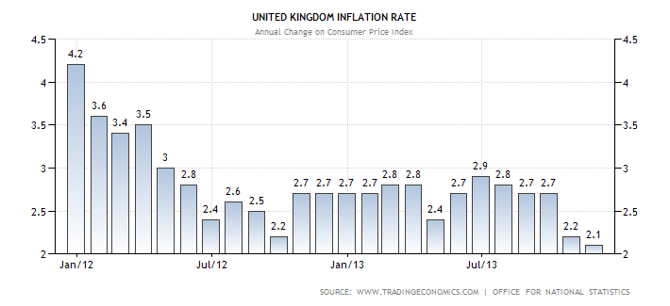

**Short and long term forecast**

Inflation is more likely than not to remain above 2% for much of the next two years. This further sustained period of above-target inflation largely reflects the impact of the depreciation of sterling earlier this year and the judgment that the unusually large contribution from administered and regulated prices will persist.

Despite that, inflation is likely to fall back to around the 2% target by 2015. A gradual revival in productivity growth, combined with persistent spare capacity, should dampen domestic cost pressures sufficiently to offset the sustained elevated contribution from administered and regulated prices.

There are a number of other sources of uncertainty affecting the outlook for inflation. As ever, inflation may be buffeted by movements in the exchange rate and commodity prices, both of which are prone to move sharply. It is unclear for how long inflation can remain above the target before it affects public perceptions of the MPC’s determination to keep inflation close to the 2% target, with potential implications for wages and prices. The path of inflation will also depend upon the extent to which companies’ profit margins are restored through higher prices, rather than through slower cost growth.

**In summary, inflation is more likely to be above than below the 2% target for much of the next two years, to around 2.5% - 3%. If you therefore hold cash deposit at this time, interest rates remain very poor but there are some 2-3 year deals around offering 3% and we will feature in autumn newsletter a table of the latest rates.**

## **4. Economic and Markets Report**

This outlook is completely independent in its focus and should not in isolation be the basis in which to make a financial decision. Please refer to your financial advisor for further advice before making any investment decision, as we are not regulated to provide financial advice.

**Stock Market Performance in 2012-2013**

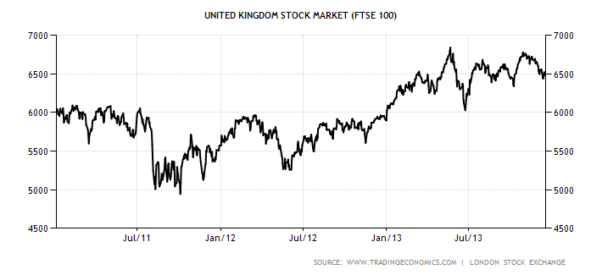

Goldman Sachs predicts an end of year target for the index of 7300. Analysts at Citigroup have also suggested a forecast of 7000, but despite this optimism, Europe and the prospect of default in the bond markets continues to haunt the rise of equities in 2013; but this fear factor is becoming weaker as world economies move out of recession.

If you are seeking income to your scheme through UK equities, the best yielding stocks over the last 12 months in the UK include: Centrica (4.71pc yield), Talktalk Telecom (5.3pc), J Sainsbury (4.7pc), Tesco (4.5pc), GlaxoSmithKline (4.6pc) and British American Tobacco (4.4pc).

In respect of best performers over 2012, these include:

| Rank | Company | % Change | Sector |
| --- | --- | --- | --- |
| 1 | Lloyds Banking Group | +85.0% | Banks |
| 2 | Aberdeen Asset Management | +73.2% | Asset Managers |
| 3 | TUI Travel | +70.4% | Travel & Tourism |
| 4 | Standard Life | +61.0% | Life Insurance |
| 5 | Royal Bank of Scotland | +60.8% | Banks |

**If you are seeking to open an online share dealing account, we have negotiated excellent rates for clients – please email us at** [**info@pensionpractitioner.com**](mailto:info@pensionpractitioner.com) **with the subject header “trading account” and we will organise this with you or in conjunction with your financial advisor.**

**Property**

In our 2012 trustee report, we advised that property yields were not expected to improve in 2013 and this has been borne out in the first quarter of 2013.

The table below breaks down where the yields are which includes high street shops, to office blocks and warehouses both inside and outside London.

|  |  |  |
| --- | --- | --- |
| **UK PROPERTY INVESTMENT YIELDS** | | |
|  |  |  |
|  | **Apr-13** | **Trend** |
| **HIGH STREET SHOPS** | **%** |  |
| Central London | 3.50 | Stable |
| Prime | 4.85 | Weaker |
| **SUPERMARKETS** | | |
| Prime | 4.75 | Stable |
| **SHOPPING CENTRES** | | |
| Prime | 5.50 | Stable |
| Best Secondary | 7.50 | Stable |
| **RETAIL WAREHOUSES** | | |
| Park - Open A1 (inc fashion) | 5.25 | Stable |
| Solus - Prime - Bulky User | 6.25 | Stable |
| **LEISURE PARKS** | | |
| Prime | 6.35 | Weaker |
| **OFFICES** | | |
| London City | 4.75 | Stable |
| M25/South East | 6.00 | **Stable(**Weaker) |
| Regional Cities | 6.25 | Weaker |
| **INDUSTRIAL** | | |
| Prime Distribution | 6.50 | Stable |
| Prime Estate (Greater London) | 6.00 | Stable |
| Prime Estate (Ex Greater London) | 6.75 | Stable |

**For clients seeking to invest into commercial property, please visit our the latest property auctions on our website at:** [**http://www.pensionpractitioner.com/latest-property-auctions**](http://www.pensionpractitioner.com/latest-property-auctions)**.**

**Economic Outlook** -material sourced from publications issued by the Bank of England.

In the United Kingdom, the economic recovery remains weak and uneven. Domestic demand increased moderately during 2012, but this was largely offset by a pronounced fall in exports. Employment continued to grow strongly. The weakness of productivity suggests that the financial crisis may still be weighing on the current effective supply capacity of the economy as well as on demand.

The MPC judges that the growth of both demand and effective supply are likely to pick up gradually over the next year or so, supported by past asset purchases, an easing in credit conditions aided by the Funding for Lending Scheme, and a continuing improvement in the global environment. But the legacy of adjustment and repair left by the financial crisis means that the recovery is likely to remain weak by historical standards.

The main risks to the recovery continue to emanate from abroad. Although financial tensions have abated since last summer, there remains a risk that the required adjustments to indebtedness and competitiveness within the euro area occur in a disorderly manner. Although the Committee’s exclude the more extreme outcomes, they embody the assumption that those adjustments will nevertheless be associated with a prolonged period of weak growth and heightened uncertainty.

**Taking those risks into account, the Committee’s best collective judgement is that the economy is likely to see a modest and sustained recovery over the next three years.**

5. Latest news

## Pension liberation

Sadly, the present economic climate is also proving rich pickings for fraudsters who prey on those facing financial difficulties. The problem of pension liberation fraud is now widespread and we are one of the firms seeking to prevent this abuse.

If you have therefore been offered a financial incentive for an investment, we strongly recommend that you notify us in order that we can ensure that the operator is blocked from further business.

**New Code of Conduct for SSAS**

The Pensions Regulator is concerned with the regulation of self administered schemes and has issued guidance in connection with the regulation of SSAS and occupational schemes generally. We welcome that revised code of conduct.

It is aimed at assisting trustees who wish their scheme to meet the quality standards that form the basis of a SSAS and sets out what the regulator considers that trustees should do to meet those standards. Details of those codes are being finalised and we will issue a special newsletter informing you of the changes and when they will come into effect.

**Investing in Agricultural Land**

We have seen schemes which have invested in agricultural land and increase in their value, this could be due to a relaxation in planning laws on conversion to commercial property. As you may know, farmers do not currently require planning permission to erect non-residential buildings on their land if those buildings are intended for agricultural use. The Department for Communities and Local Government has confirmed that only existing farm buildings will be eligible for the new change-of-use rules. New barns can also only be converted after 10 years’ of agricultural use.

The new rules will also increase the scope of “permitted development” rights that facilitate changing the use of offices into shops. A development from this will be conversion to residential property and therefore long term investment into agricultural land with pre-existing non-residential buildings could offer a good investment yield.