# 2014 Annual Report

**to the Trustees of**

# Hammerhead

# TV Pension

# Scheme No 1

# 

# 

Prepared by



# Index

1. Introduction
2. Pension scheme return
3. Inflation report 2014 and outlook for 2015
4. Economic and markets report
5. Latest news
6. **Introduction**

We are pleased to enclose our annual report to the Trustees following completion of your tax return.

This report provides a copy of our tax submissions to HM Revenue & Customs on your behalf, together with our comments where relevant. Please take the time to review this and advise us of anything that you are not in agreement with.

In addition to this, we have also prepared the following for you:

* + Inflation report and outlook for 2014 & 2015. The purpose of the inflation report is to help your investment decisions, having regard to the likely direction of inflation over the next 12 months.
  + Economic and markets report. This summarises in what markets returns are being made, and the likely return on certain asset classes, such as property and equities for the next 12 months.
  + A recent news update in the pensions industry. The pensions industry is constantly changing and we have summarised the key issues and how you may be affected.

 • Copy of most recent newsletter. In case you have not received our most recent newsletter, we attach our latest with our compliments.

Our role is to ensure that the tax privileges for your pension scheme are maintained. In addition, we seek to add value by providing you with information so that in conjunction with your investment advisor you maximise the growth of your pension fund, in a tax efficient way for you and your business.

Finally, thank you for choosing us to act as the Practitioner for your pension scheme.

# Pension Scheme Return

**Details**

|  |  |  |
| --- | --- | --- |
| Pension Scheme Tax Reference |  | 00071696RT |
| Pension Scheme Name |  | Hammerhead TV  Pension Scheme No 1 |
| Is the scheme an Occupational scheme? |  | Yes |
| Tax Year ended |  | 05 Apr 2014 |
| Date submitted |  | 21 Oct 2014 |
| Submitted by |  | Pension Practitioner  .Com Limited |
| Scheme Administrator |  | Mr Nigel Alan Hoban |

|  |  |  |
| --- | --- | --- |
| Amended Return |  | No |

|  |  |  |
| --- | --- | --- |
| Accounting Period |  | 06 Apr 2013 - 05 Apr 2014 |

|  |  |  |
| --- | --- | --- |
| During this period, was the aggregate of payments to and from the scheme greater than £100,000? |  | No |
| Specify the aggregate of payments to and from the scheme |  | £48751 |

|  |  |  |
| --- | --- | --- |
| At the end of this period, did the scheme have assets with a total value before pension liabilities greater than £400,000? |  | Yes |

**Connected Parties**

|  |  |  |
| --- | --- | --- |
| At any time during the period from 06/04/2013 to 05/04/2014 did the scheme either directly or indirectly own assets that it had acquired from either: a. a sponsoring employer or any person connected with that employer? *or* b. a person who was a director of or a person connected to a director of a close company that was also a sponsoring employer? *or* c. a person who was either a sole owner or partner or a person connected with the sole owner or partner of a business which was a sponsoring employer? *or* d. a member or person connected with a member? |  | No |

**Cash and Bank Information**

|  |  |  |
| --- | --- | --- |
| Total amount of all cash and bank balances at the beginning of the period |  | £262 |
| Total amount of all cash and bank balances at the end of the period |  | £18064 |
| Total amount of interest credited to these accounts |  | £0 |

**Arms Length Transactions**

|  |  |  |
| --- | --- | --- |
| Total cost or market value of any assets owned at the end of the period Specify whether this amount is |  | £857301  Market value |

|  |  |  |
| --- | --- | --- |
| Nature of asset(s) acquired |  | Quoted shares |
| Total cost of any assets acquired |  | £11230 |

|  |  |  |
| --- | --- | --- |
| Nature of asset(s) disposed |  | Quoted shares |
| Total consideration received from the disposal of any assets |  | £57496 |
| Were any disposals made to a connected party or parties? |  | No |

|  |  |  |
| --- | --- | --- |
| Total amount of income from assets received |  | £12832 |

# Inflation Report 2013, 2014 and

**2015 Outlook**

## It is important to consider the effects of inflation on pension funds to ascertain any real growth in a pension scheme. Simply put, if your pension fund return over the tax year exceeds that of inflation your fund has grown in real terms and has maintained purchasing power.

After a period of generally disappointing growth in 2011 and 2012, the UK economy has shown clear signs of recovery in 2013.

GDP growth is expected, picking up from 0.1% in 2012 to around 1.4% in 2013 and around 2.4% in 2014. Risks to growth are now more balanced, with both upside and downside possibilities.

Non-financial services sectors will remain the main engine of growth in both output and employment, as has been the case for the last four years. These services sectors are playing an increasingly important role in driving UK export growth.

Consumer price inflation is likely to remain above target at around 2.4% in 2014, although this would represent a fall from 2.7% in 2013. There could be upside risks to inflation from any renewed rise in global commodity prices next year.

Persistently above target inflation contributes to a continued decline in real earnings growth in 2013 and 2014, making six successive years of negative real growth. A gradual recovery is expected in real earnings in 2015-2017, but the level of real earnings in 2017 would nonetheless remain around 6% below its peak level in 2008 in our main scenario.

Subdued real earnings growth should, however, help to keep total UK employment growing at a healthy rate over the next four years, despite continued public sector job losses over this period.

A gradual recovery in consumer spending growth is expected over the next few years, helped by rising incomes from employment and stronger house prices.

## GDP Growth & Inflation (CPI) 2013 & projections for 2014

**Key projections**

|  |  |  |  |
| --- | --- | --- | --- |
|  | 2013 |  | 2014 |

Real GDP Growth 1.40% 2.40%

Inflation (CPI) 2.70% 2.40%

Source: PwC main scenario projections

## Short and long term forecast

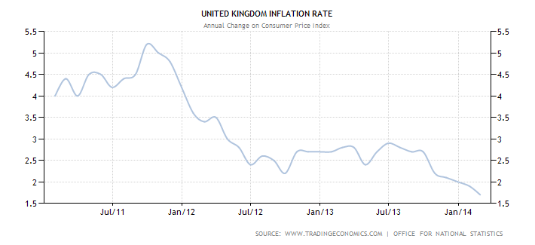

**In summary, inflation is more likely to be above than below the 2% target for much of the next two years, to around 2.5% - 3%. If you therefore hold cash deposit at this time, interest rates remain very poor but there are some 2-3 year deals around offering 3%. Our newsletters will have a table of the latest rates to keep you up to date quarterly.**

1. **Economic and Markets Report**

This outlook is completely independent in its focus and should not in isolation be the basis in which to make a financial decision. Please refer to your financial advisor for further advice before making any investment decision, as we are not regulated to provide financial advice. If you do not have a financial adviser we can introduce one to you.

## Stock Market Performance 31 March 2013 - 31 March 2014

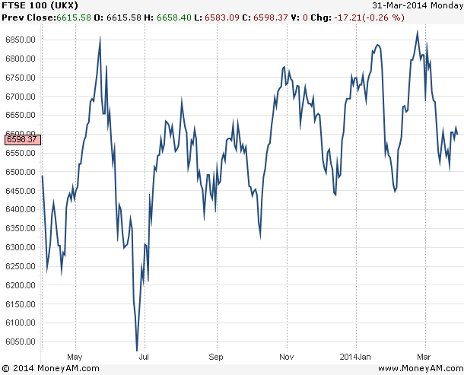

Peter Oppenheimer, chief global equity strategist at [Goldman Sachs](http://data.cnbc.com/quotes/GS), predicts that the FTSE 100 will have hit 7,500 by the end of 2014, boosted by a stronger U.K. recovery.

Many are predicting the index will beat its previous high of 6,950, set back in 1999. While it has never scaled 7,000 before, strategists at [Citi](http://data.cnbc.com/quotes/C) forecast it will reach 8,000 next year.



## TOP 10 RISERS AND FALLERS OVER THE LAST SIX MONTHS



|  |  |  |  |  |  |
| --- | --- | --- | --- | --- | --- |
| **Risers** | **Price** | **%** | **Fallers** | **Price** | **%** |
| [**Gulf Marine Wi**](http://investing.thisismoney.co.uk/quote/GMS/Gulf-Marine-Wi-Ord-10p-wi-share-price)[**Ord...**](http://investing.thisismoney.co.uk/quote/GMS/Gulf-Marine-Wi-Ord-10p-wi-share-price) | 151.25p | **143,947.62** | [**JPMorgan US Smaller...**](http://investing.thisismoney.co.uk/quote/JUSC/JPMorgan-US-Smaller-Companies-IT-share-price) | 161.50p | **-89.72** |
| [**Circassia...**](http://investing.thisismoney.co.uk/quote/CIR/Circassia-Pharmaceuticals-Ord-008p-share-price) | 298.75p | **13,177.78** | [**Tejoori Limited**](http://investing.thisismoney.co.uk/quote/TJI/Tejoori-Limited-share-price) | 0.13p | **-67.50** |
| [**Astar Minerals Ord...**](http://investing.thisismoney.co.uk/quote/ASTA/Astar-Minerals-Ord-01p-share-price) | 1.05p | **854.55** | [**Hightex Group**](http://investing.thisismoney.co.uk/quote/HTIG/Hightex-Group-share-price) | 0.43p | **-64.17** |
| [**IRF European...**](http://investing.thisismoney.co.uk/quote/IRF/IRF-European-Finance-Investments-share-price) | 0.08p | **814.29** | [**Partnership Assurance...**](http://investing.thisismoney.co.uk/quote/PA./Partnership-Assurance-Group-share-price) | 138.30p | **-57.05** |
| [**Verdes Management**](http://investing.thisismoney.co.uk/quote/VMP/Verdes-Management-share-price) | 0.70p | **677.78** | [**Strategic Natural...**](http://investing.thisismoney.co.uk/quote/SNRP/Strategic-Natural-Resources-share-price) | 4.13p | **-55.95** |
| [**Kea Petroleum**](http://investing.thisismoney.co.uk/quote/KEA/Kea-Petroleum-share-price) | 3.18p | **202.86** | [**Tricor**](http://investing.thisismoney.co.uk/quote/TRIC/Tricor-share-price) | 2.38p | **-54.67** |
| [**Emmit Ord 0.001p**](http://investing.thisismoney.co.uk/quote/EMT/Emmit-Ord-0001p-share-price) | 55.00p | **144.44** | [**Future**](http://investing.thisismoney.co.uk/quote/FUTR/Future-share-price) | 6.35p | **-54.64** |
| [**LP Hill**](http://investing.thisismoney.co.uk/quote/LPH/LP-Hill-share-price) | 9.00p | **80.00** | [**Oxford Technology...**](http://investing.thisismoney.co.uk/quote/OXT/Oxford-Technology-Venture-Capital-Trust-share-price) | 35.00p | **-53.33** |
| [**Kennedy Ventures**](http://investing.thisismoney.co.uk/quote/KENV/Kennedy-Ventures-share-price) | 2.95p | **76.12** | [**Premier Foods**](http://investing.thisismoney.co.uk/quote/PFD/Premier-Foods-share-price) | 70.38p | **-51.13** |
| [**CSF Group**](http://investing.thisismoney.co.uk/quote/CSFG/CSF-Group-share-price) | 6.13p | **69.10** | [**Kromek Group**](http://investing.thisismoney.co.uk/quote/KMK/Kromek-Group-share-price) | 37.50p | **-50.33** |

**If you are seeking income to your scheme through UK equities, the best yielding stocks over the year 2013 in the UK include:** Vodafone Group (8.7pc), Resolution (6.96pc), Morrison Supermarkets (6.17pc), RSA Insurance Group (6.02pc), Centrica (5.18pc), Glaxosmithkline (4.89pc), BAE Systems (4.85pc)



Surprisingly, the top performer in the FTSE 100 over the year 2013 is not a financial company, or a precious metals firm, but rather an airline. IAG, the holding company for Iberia and British Airways, almost doubled its value in 2013, climbing from 194p to 380p. Another strong performer was Easyjet. The budget airline climbed from 794p in January to reach a peak of 1500p in December. Some of the worst performing stocks on the FTSE 100 during the year 2013 include Gold and Silver mining companies.

## If you are seeking to open an online share dealing account, we have negotiated excellent rates for clients – please email us at [info@pensionpractitioner.com](mailto:info@pensionpractitioner.com) with the subject header “trading account” and we will organise this with you or in conjunction with your financial advisor.

**Property**

The big jump in UK commercial real estate investment activity in Q4 2013 drove accelerating growth in prime rents and yields, according to the CBRE’s latest Index. UK commercial property rents increased by 0.5% over the last quarter resulting in rental value growth of 2.7% for 2013. The average prime yield fell by 9.2 base points over the quarter and stood at 6.0% at the end of Q4 2013.

In Q4 2013 the office sector was again the strongest in terms of rental growth. The number of locations with rising rents increased (from 34 in Q3 to 90 in Q4 2013) and contributed to a prime rental growth of 2.0% over the quarter and 7.3% over the year. As was seen in previous quarters, Central London offices recorded a strong performance with rental value growth of 2.3% over the last quarter. Office rental growth was mainly driven by the large improvements in rents in City, Midtown and Southbank. However, significant rents improvements were also seen in the rest of the UK. Rental value growth in UK offices is following a distinctive geographical pattern. The South part of the UK recorded positive rental value growth, while prime rents in the North of the UK remained flat or fell over the last quarter. This has been the pattern for most of this year. However, each quarter it is evident that the range of the growth is increasing.

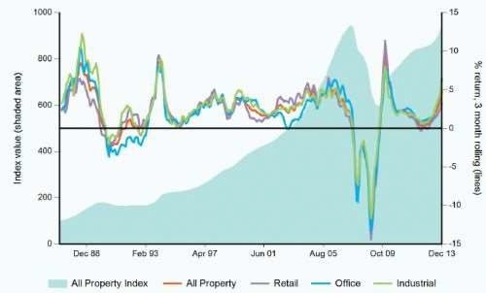

UK commercial property returned 10.9% in 2013, according to the IPD UK Monthly Property. The IPD UK Monthly Property Index measures ungeared total returns to directly held standing property investments from one open market valuation to the next and for February 2014 returned 1.1%.

In the retail sector, the average rate of growth continued to be slow. High street shops recorded 0.6% rental value growth for the quarter with contributions coming not only from London but also from the South East, Midlands and North East. Prime rents for shopping centres increased across the UK, while retail warehouses recorded negative rental value growth across most regions, a trend that was evident throughout 2013.

Overall, average prime yields decreased across the country. The biggest fall was recorded in the industrial sector, with an average drop of 47 base points to 6.7% in last quarter of the year. This is the lowest yield recorded in the sector since Q4 2007. Although industrial property in all UK regions recorded a fall in yields, it is notable that the biggest falls were recorded in London.

The office sector is also experiencing an accelerating decline in yields with the weighted average prime reaching 5.7% in Q4 2013. As in the industrial sector, all the UK regions recorded a fall in office yields.

In retail sector, yields continued to fall, but at a slower pace than in the other sectors. Although there is no single location that recorded an increase in yields, only in 30% of monitored retail locations recorded fall in yields, compared with over 80% of the office and industrial locations.

# Latest news

## Pension liberation

As you may be aware, as part of HMRC’s continuing strategy to combat pension liberation, on 21 October 2013 they made a number of changes to try to strengthen existing processes to deter pension liberation and safeguard pension savings. These changes related to new applications to register pension schemes and for dealing with requests for information about the tax status of a receiving scheme for a proposed transfer.

Pensions liberation fraud is now widespread and as a reputable SSAS provider, it is our duty to protect our clients from fraudulent companies.

If you have therefore been offered a financial incentive for an investment, we strongly recommend that you notify us in order that we can ensure that the operator is blocked from further business.

## Increasing Pension Flexibility

The following measures increase flexibility in relation to pension savings:

a reduction of the minimum income threshold for flexible drawdown from

£20,000 to £12,000 (for applications for flexible access made on or after 27 March 2014);

allowing members over 60 with total pension savings of £30,000 or less to take the whole amount as one or more trivial commutation lump sum (for commutation periods starting on or after 27 March 2014);

removal of the revaluation factor in calculating the portion of the commutation limit absorbed by previous benefit crystallisations;

an increase from £18,000 to £30,000 in the limit for lump sums from small pots where an annuity is in payment (for payments made on or after 27 March 2014);

an increase in the general small pots limit from £2,000 to £10,000 – this also applies in cases where transitional protection of lump sums in excess of 25% of total pension rights applies (for payments made on or after 27 March 2014); and an increase in the number of lump sums from small pots that can be taken to 3.

## Lifetime Allowance and Annual Allowance

|  |  |
| --- | --- |
| 2014/2015  Annual Allowance | £40,000 |
| Lifetime Allowance | £1,250,000 |
| 2013/2014  Annual Allowance | £50,000 |
| Lifetime Allowance | £1,500,500 |

Any unused annual allowance can be carried forward for up to three years.

## INHERITANCE TAX Deaths after 5/4/2012

Threshold / Nil-rate band £325,000

Death rate 40%

Lower death rate 36%

(10% or more given to charity)

Chargeable lifetime transfers rate 20%

## Regulated Advice

The Perimeter Guidance (Pension Activities) Instrument 2006 came into force on 6 May 2006 and there is a special exemption for SSAS, on the basis that the trustees are really making investment decisions for themselves, rather than for a wider membership.

Although as Trustee you are investing your money for yourself, you should consider but are not compelled to seek advice from a regulated person prior to investing your funds. All scheme members are trustees via Pension Practitioner .Com. We will not be a Trustee of the Scheme. If you do not have a financial adviser we can recommend one to you.

Finally, we provide administration services and guidance to small business owners as trustees of small self administered schemes. We do not provide regulated advice and as such cannot recommend whether a small self administered scheme is suitable for your circumstances. You are recommended to seek financial advice on this.