Geoffrey Jones

Marchants Barn

Marchants Close

Hurstpierpoint

Hassocks

West Sussex

BN6 9UZ

Pension Schemes Services

HM Revenue and Customs

BX9 1GH

16th January 2019

Via post and email: [pensionschemes@hmrc.gov.uk](mailto:pensionschemes@hmrc.gov.uk)

Dear Sirs

**Pension Scheme Administrator registration proforma**

Please find enclosed a completed and signed Pension Scheme Administrator registration form in order to apply for an administrator ID number.

I look forward to hearing from you at your earliest convenience.

Yours Faithfully,

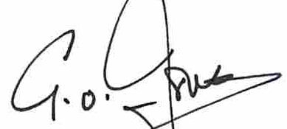

Geoffrey Jones