Amanda Isham

4 Middleton Close

Gillingham

Kent

ME8 9LR

HM Revenue and Customs

Pensions Schemes Services

BX9 1GH

Date: 10thAugust 2018

**SRN: S0000000136**

**Pension Scheme Name: Elit SSAS**

Your Ref: APSS530

Sent by: Post Recorded Delivery

Dear Mr Bhandal,

Further to our previous letter to you dated 6th August 2018, in response to your 14 point letter, we write to you again to update you with the Corporation Tax Number, which was previously unknown at the time of my previous letter. Apologies, we were keen to reply to your 14 point letter.

To finalise the response to your point 11. The Scheme Establisher, the corporation tax number for Elit Consulting Limited is 623C3006617484.

We trust that the above covers everything you require to tax register the scheme and we look forward to hearing from you.

Yours sincerely,

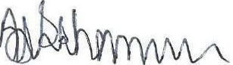

Amanda Isham