AVIVA

PO BOX 520

Norwich

NR1 3WG

23rdJune 2022

Richard Kenneth Edwards

AVIVA Plan Number: TK91023093

To Whom it may Concern,

Please find enclosed a completed application from Richard Edwards to transfer his pension out, together with the following documents:

1. Pension Transfer Discharge Form
2. Trust Deed and Rules
3. HMRC Screen shot
4. HMRC Tax Registration Letter
5. TPR Registration
6. ICO registration - will follow shortly
7. Bank Statement
8. Bank account details
9. Company Letter
10. March 2022 Payslip
11. April 2022 Payslip
12. May 2022 Payslip
13. Contribution Schedule

I would be most grateful if you may process Mr Edwards request at your earliest convenience. Should you require any further information, please do not hesitate to contact us.

Yours Sincerely

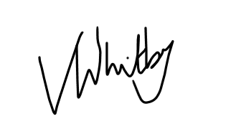

Vikki Whitby

Scheme Administrator